Project 8.1b Model An Arbor Press

Introduction
Have you ever done a skateboard trick or strapped on a pair of in-line skates? What is used between the wheels and axles to allow the wheels to spin while the axles remain stationary? Wheel bearings fit snugly inside the bored holes of the wheels and are held in place by friction. In fact, they are pressed into position with devices that are similar to an arbor press.

An arbor press is used to press objects together or force them apart. Typical arbor press applications include pressing bearings into gears or pulleys, pressing gears or pulleys onto shafts, and pressing alignment pins into fixtures. The arbor press shown in this project is powered by an air-actuated rotary cylinder, while the lever-type version is powered by human muscle.

Interpreting dimensioned drawings is an important engineering skill. Using drawings to create a computer model of a part is also important. You learned earlier in this course that a sketch is the documentation foundation for related technical work. Communicating this information effectively allows a group of people to function as a design team.

In this project you will further develop your modeling skills and your ability to use a computer as an efficient communication tool. The skills that you learned earlier in this course will be systematically applied to model the eight remaining parts needed for the Arbor Press Assembly. The parts with the dimensions are listed below.

Equipment
Computer with 3D CAD solid modeling program
Engineering notebook
CAD Files (Part_5, Part_12a, Part_12b, Part_13)

Procedure
- Model and assemble the parts shown using the drawings provided.

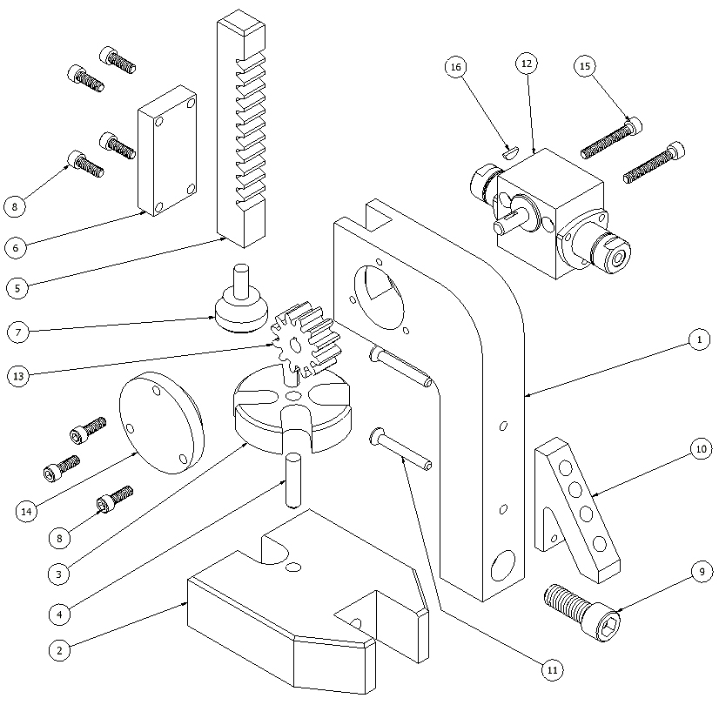

Parts List
Item | Quantity | Name | Description | Material
1 | 1 | Column |  | AL 6061
2 | 1 | Base |  | AL 6061
3 | 1 | Table |  | AL 6061
4 | 1 | Table Pin |  | AL 6061
5 | 1 | Rack |  | AL 6061
6 | 1 | Cover Plate |  | AL 6061
7 | 1 | Rack Pad |  | AL 6061
8 | 7 | Cover Plate Screw | 8-32 UNC x .50 cap screw | STL
9 | 1 | Column Screw | 3/8-16 UNC x 1.00 cap screw | STL
10 | 1 | Punch Holder |  | AL 6061
11 | 2 | Punch Holder Screw | 8-32 UNC x 1.25 flat countersunk head cap screw | STL
12 | 1 | Rotary Actuator | Bimba PT-006360-A1DV
13 | 1 | Gear |  | AL 6061
14 | 1 | Gear Plate |  | AL 6061
15 | 2 | Actuator Screw | 8-32 UNC x 1.25 cap screw ground to 1.1 length | STL
16 | 1 | Key | Woodruff Key # 202.5 | STL

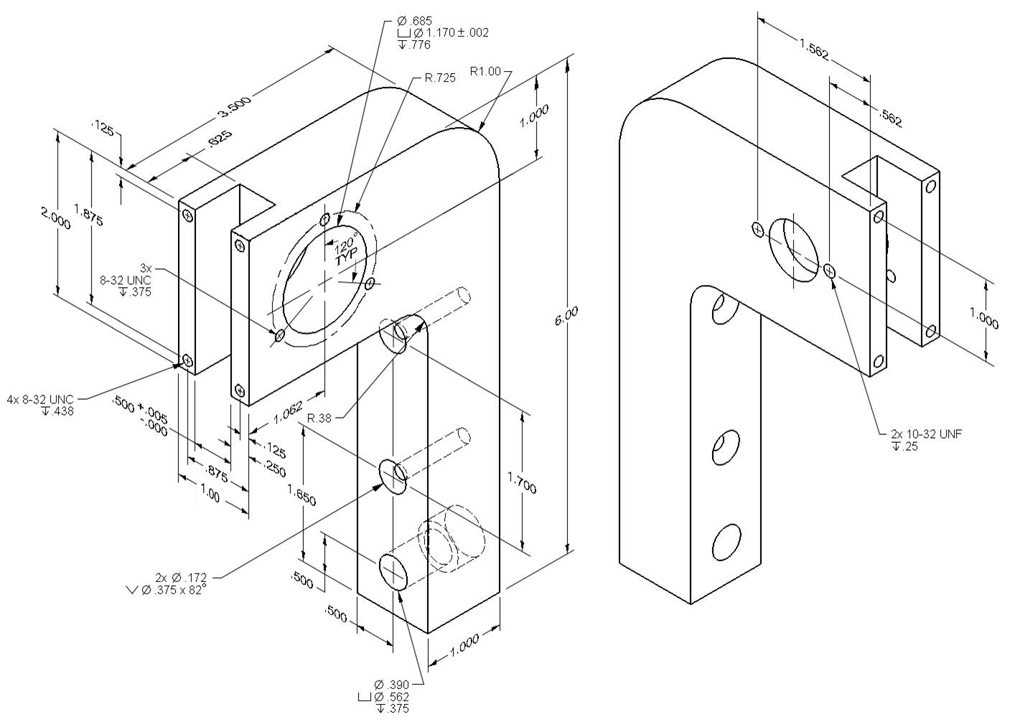
Part #1: Column FAO 63 μIN

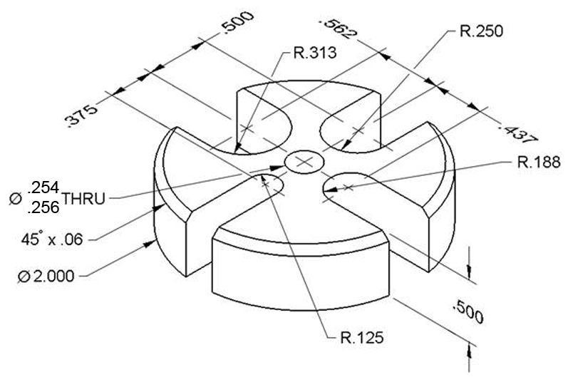
Part #3: Table FAO 63 μIN
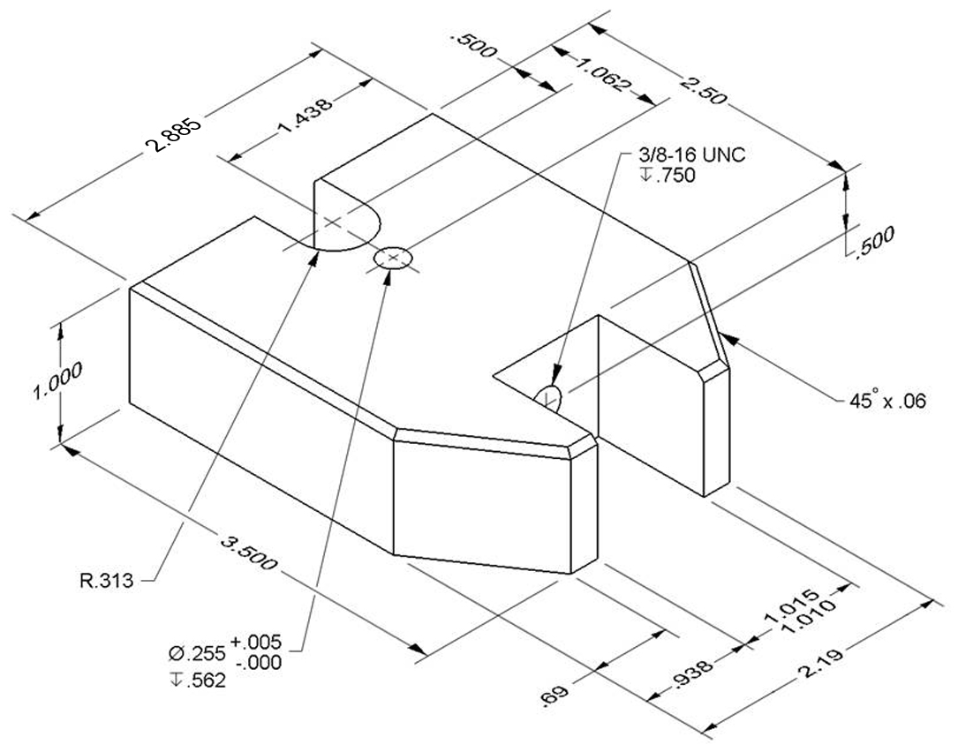
Part #2: BaseFAO 63 μIN

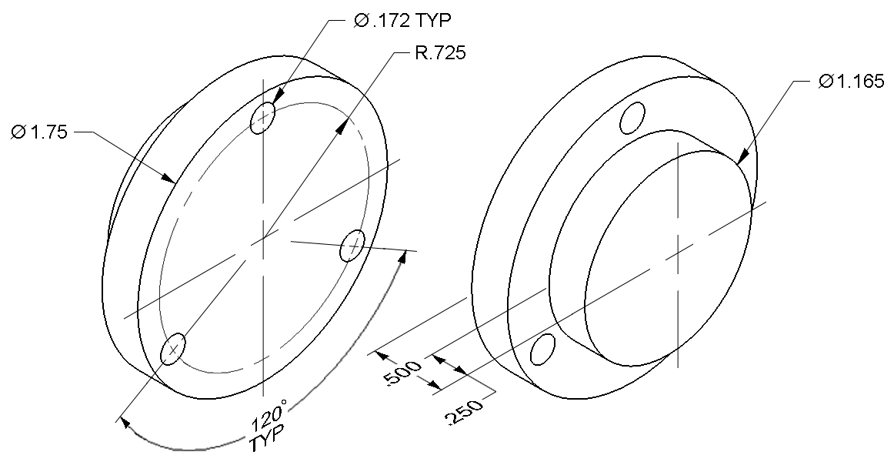
Part #14: Gear Plate FAO 63 μIN

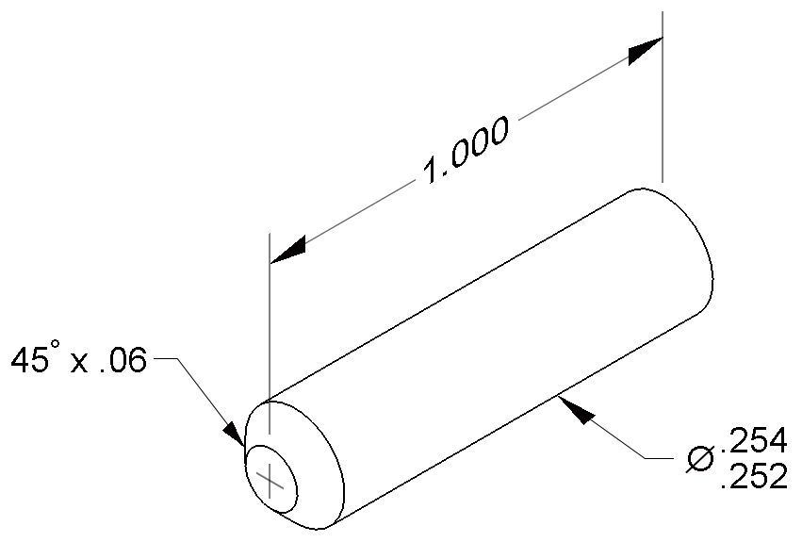
Part #4: Table Pin FAO 63 μIN

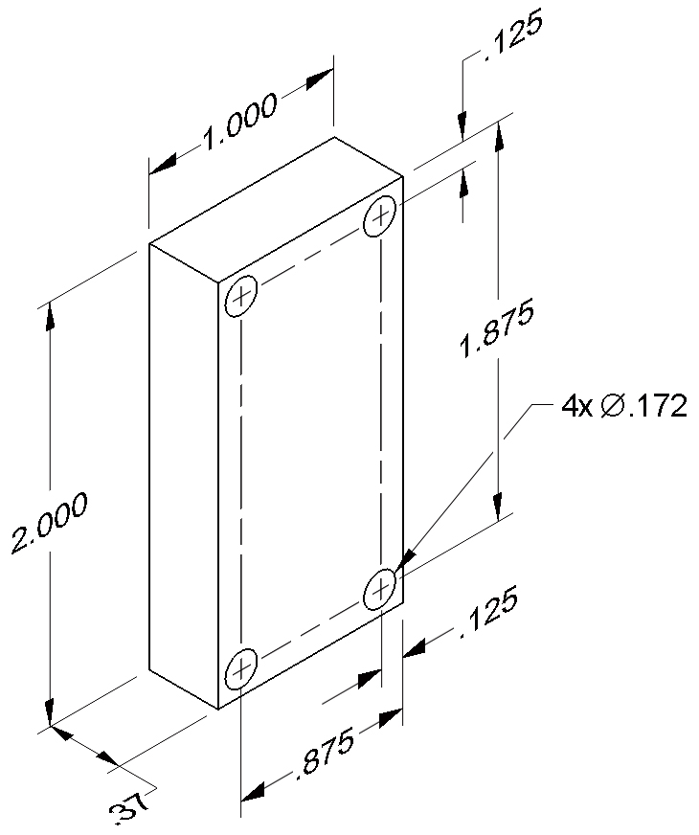
Part #6: Cover Plate FAO 63 μIN

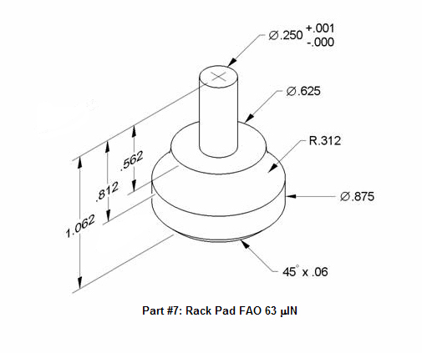

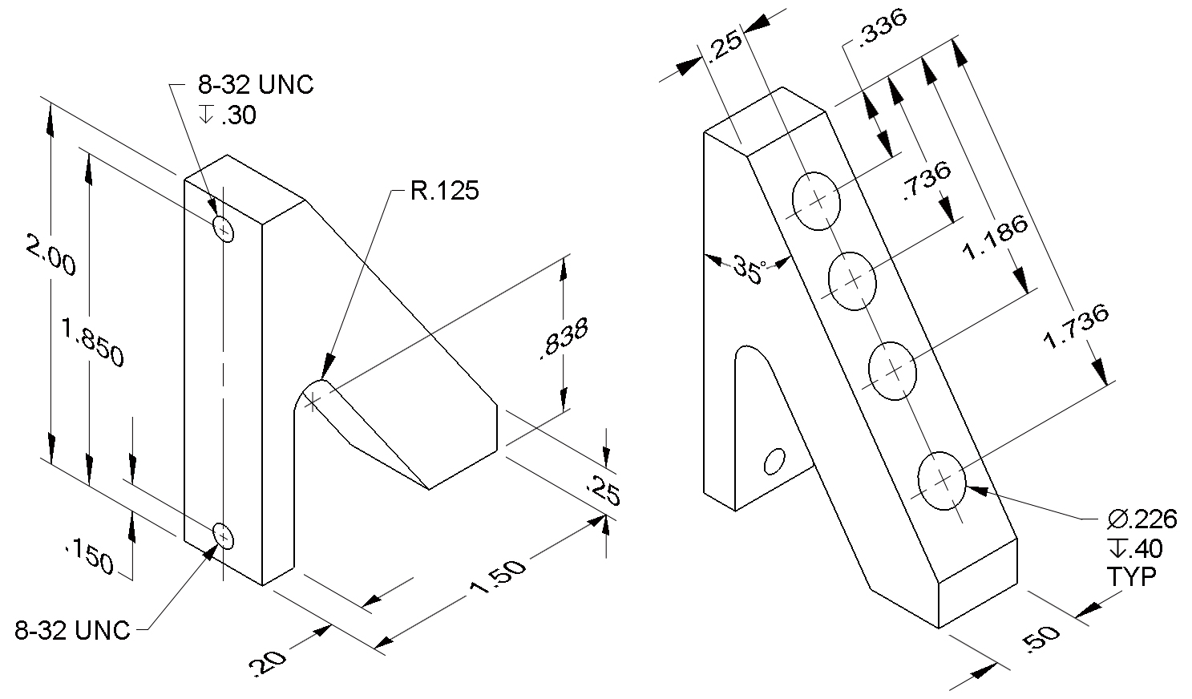
Part #10: Punch Holder FAO 63 μIN

Enhancing your Skills
- Confirm with your teacher before modeling these two parts.
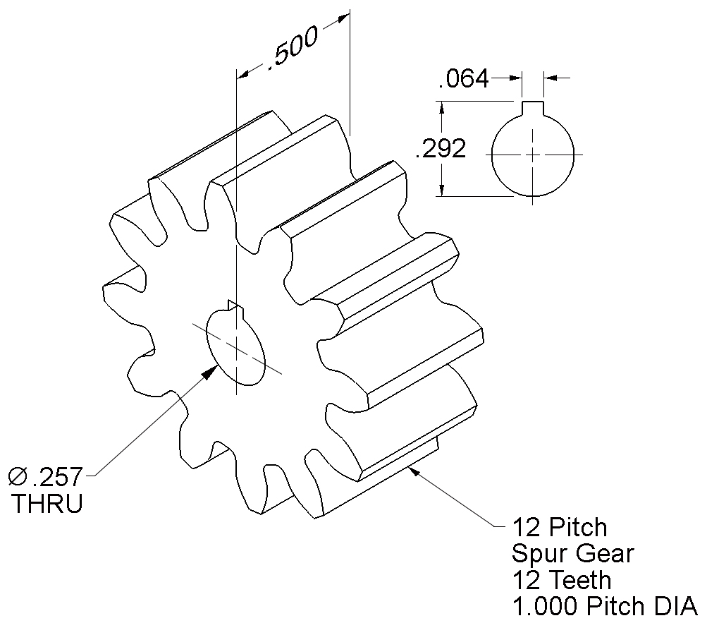
Part #13: Gear FAO 63 μIN

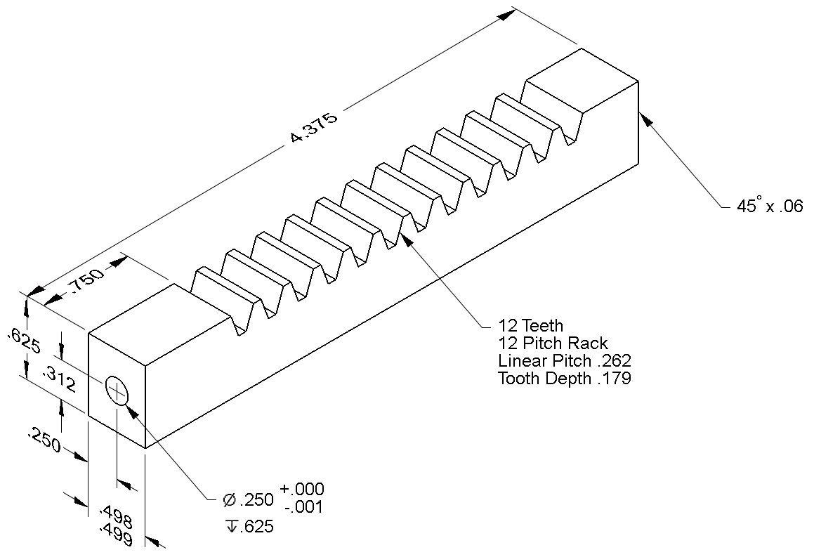
Part #5: Rack FAO 63 μIN

Conclusion
- Why are drawings composed of different line conventions?

- What is the purpose of a sectional view?

- What is the purpose of an auxiliary view?

- Why are symbols used instead of words to identify hole types?

- What is the format for calling out a tapped hole?

- What advantage is there to using algebraic equations instead of numerical values when defining the dimensions of a CAD model?

- What three types of constraints can be applied to CAD sketches or models?

- How would a consumer most likely come into contact with an assembly view drawing?

- What advantages do CAD drawings have over paper sketches?

