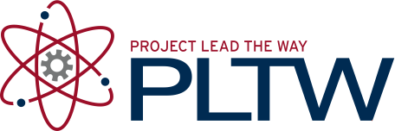

Project 1.2.15 Glider Design: Long Distance Flight Phase 2

Introduction
In this project, you will submit a proposal to the Department of Education to provide a glider design to meet the following criteria. All submissions should have the primary design goal to be optimized for long distance, straight-line flight through a contained medium (indoor flight conditions).

Equipment
- Engineering notebook
- Pencil
- PC with AERY glider design software
- Printer

Procedure
Phase Two Funding
Funding in Phase Two shall make available all necessary materials and resources required for the construction and manufacturing of a glider should the proposed design be found suitable. Successful phase two proposals will provide ample evidence that the design proposed either meets all design requirements through rigorous testing or has been modified to meet such requirements.
Glider Design Requirements
- Sustain flight over the longest possible distance in a straight line.
- Be of original design by teams of no more than three developers.
- Utilize standard AERY Software format for design development and output.
- Utilize standardized construction materials (Balsa, adhesives, etc.).
- Have decorations that are creative and attractive.
- Be durable enough to survive normal launch, flight, and landing conditions with little or no harm to its structure.
- Be able to be launched by catapult. (See specifications diagram)

Proposal Evaluation
Prototype development work beyond the design phase must only occur after the submission of this proposal. All proposals require the approval of the Department of Education designated representative prior to transitioning to prototype construction and testing stages of development
Submission Format
All entries for consideration must use the template provided.
Submissions are due no later than: ____________ at ____________.

