Intro to Engineering & Design
Name:_________________________________
Date:_____________________ Hr.____________
EOC Study Guide
50 bonus points Completed and turned in on Day of EOC – Answers will be checked. Any silly answers will result in a zero out of 50.

Unit 1 – Design Process – 22%

- How might we create the best possible solution to a problem?

- What is the most effective way to generate potential solutions to a problem? How many alternate solutions should you generate?

- What is an engineer? What types of work do engineers do?

- Why Keep an Engineering Notebook?

- What are the 4 best Practices for the Engineering Notebook?

- Explain the concept of proportion. How does the concept of proportion relate to creating a realistic sketch?

- Why would the ability to create realistic sketches make a person a more competent designer?

- What is the purpose of sketching your ideas?

- Define and differentiate invention and innovation.

- Match the following words with their definitions

____Brainstorm

____Constraint

____Design

____Design Brief

____Design Statement

____Engineering Notebook

____Prototype

____Research

- A group technique for solving problems, generating ideas, stimulating creative thinking,

- A limit to a design process: may be such things as appearance, funding, space, materials, and human capabilities.

- An iterative decision-making process that produces plans by which resources are converted into products or systems that meet human needs and wants or solve problems.

- A written plan that identifies a problem to be solved, its criteria, and its constraints.

- A part of a design brief that challenges the designer, describes what a design solution should do without describing how to solve the problem, and identifies the degree to which the solution must be executed.

- A book in which an engineer will formally document, in chronological order, all of his/her work that is associated with a specific design project.

- A full-scale working model used to test a design concept by making actual observations and necessary adjustments.

- The systematic study of materials and sources in order to establish facts and reach new conclusions.

- Put into order the Design Process steps and define each step.
_____) Define Problem
_____) Construct and test Prototype
_____) Present Solution
_____) Evaluate Solution
_____) Generate Concepts
_____) Develop a Solution

- Read through the Engineering Disciplines Power Point and write Each Engineering Field mentioned and one sentence describing what that Engineering Field does.

Unit 2: Technical Sketching and Drawing 11%

- The representation of light and shade on a sketch or map._________________

- Match the words to the proper definition.

_____Center Line

_____Extension Line

_____Dimension Line

_____Object Line _____Construction
_____Hidden Line

  - Line lightly drawn lines to guide drawing other lines and shapes.
  - Line which represents where a dimension starts and stops.

  - A line which defines the center of arcs, circles, or symmetrical parts
  - A line type that represents an edge that is not directly visible.

  - A heavy solid line used on a drawing to represent the outline of an object.

  - A line which represents distance

15. Match the words to the proper definition.

_____Orthographic Projection

_____Leader Line:

_____Cabinet Pictorial

_____Cavalier Pictorial

_____Pictorial Sketch

_____Isometric Sketch

_____Perspective Sketch

_____Multi-View Drawing

_____Oblique Sketch
- A drawing which contains views of an object projected onto two or more orthographic planes.

- Line which indicates dimensions of arcs, circles and detail.

- A method of representing three-dimensional objects on a plane having only length and breadth. Also referred to as Right Angle Projection

- Oblique pictorial where height, width, and depth are represented at full scale.

- A sketch that shows an object’s height, width, and depth in a single view

- A form of pictorial sketch in which vanishing points are used to provide the depth and distortion that is seen with the human eye.

- Oblique pictorial where depth is represented as half scale compared to the height and width scale.

- A form of pictorial sketch in which all three drawing axes form equal angles of 120 degrees with the plane of projection.

- A form of pictorial in which an object is represented as true width and height, but the depth can be any size and drawn at any angle.

- What are the 3 spatial Dimensions? _____________, ___________, and ______________________

- A method of representing three-dimensional objects on a plane. ______________________

- A drawing which contains views of an object projected onto two or more orthographic planes______________________

- A drawing that is used to show the material, size, and shape of a product for manufacturing purposes. ______________________

Unit 3 Measurement and Statistics 13%

- The Degree of closeness of measurements to the actual or accepted value is called ________________________

- Describe the difference between the meaning of the terms accuracy and precision in scientific measurement.

- How can statistical and analyzed data be used to inform, justify, and validate a design or process?

- What is dimensional analysis and how can it help solve problems involving quantities?

- Why do engineers generally adhere to a set of dimensioning standards and guidelines?

- Convert the following – Show work, conversion faction and units.
  - 2.375 Meters to yards._____________________________
  - 23,439 milliliters to liters. _____________________________
  - 13 thousand microseconds to seconds. _____________________________
  - 9.25 yards to feet. _____________________________
  - 1.15 feet to inches. _____________________________
  - 5 ft – 6 ½ in. to inches. _____________________________
  - 4 ft – 3 inches to decimal feet. _____________________________
  - 67.5 cm to inches. _____________________________
  - 1.7 yards to inches. _____________________________
- Why would you have to know how to convert measurements when looking at a technical drawing?

- Why is placement of your dimensions so important?

- How can you use units help you solve a problem?

- Why do designers need to fully dimension a part?

- What does it mean when a sketch is over dimensioned?

- A graph of vertical bars representing the frequency distribution of a set of data is called____________________________

- Collection of methods for planning experiments, obtaining data, organizing, summarizing, and presenting, analyzing, interpreting, and drawing conclusions based on data. ______________________

- The ______________________is a measure of the spread of data values

- A function that represents the distribution of variables as a symmetrical bell-shaped graph. ______________________

- The value that occurs most frequently in a given data set ______________________

- The______________________ is the difference between the largest and smallest values that occur in a set of data.

- A measure of center in a set of numerical data______________________

- The digits in a decimal number that carry meaning contributing to the precision or accuracy of the quantity ______________________

- What is Central Tendency? ________________________________________________________________________________________________________________________________

- A full-scale working model used to test a design concept by making actual observations and necessary adjustments. ______________________
- A measuring instrument having two adjustable jaws typically used to measure distance or thickness. ______________________
Record the following readings from the Calipers in the pictures
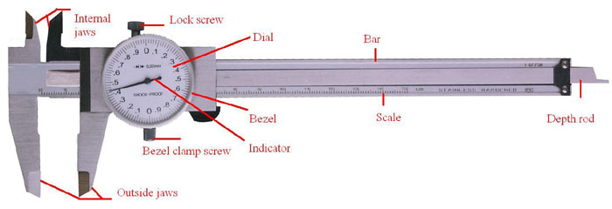

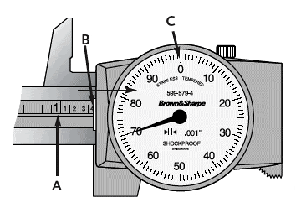

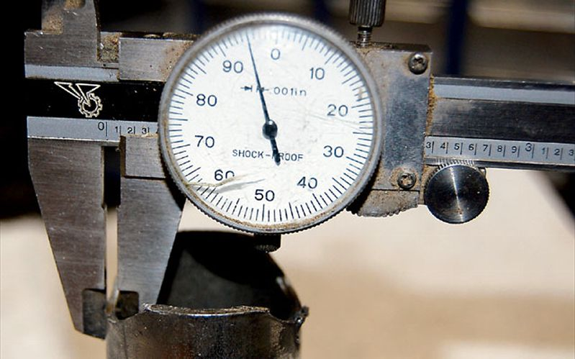

- ______________________ 42. __________________________
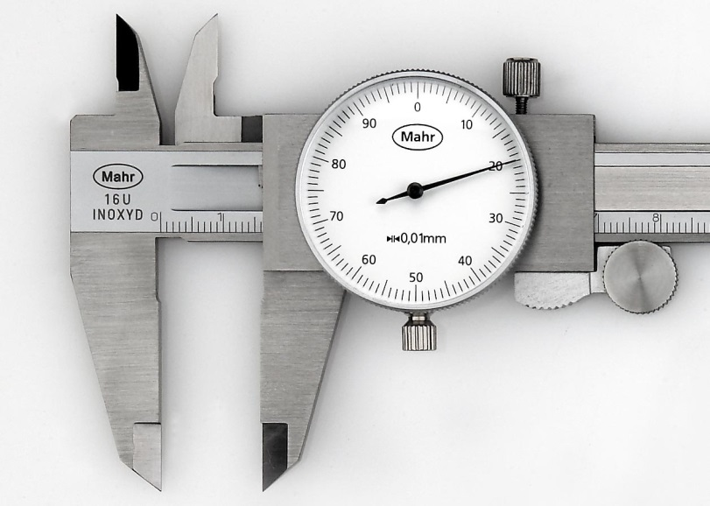
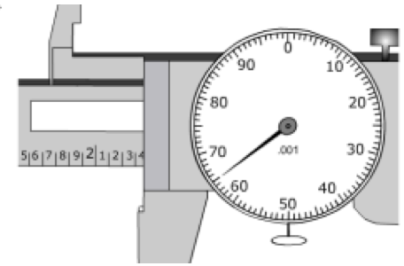

43. ________________________________ 44. ____________________________
Unit 4 Modeling Skills 4%

- What is the role of models in the design process?

- How can we use technology to make the design and manufacture of a product more efficient and less prone to error?

- What is the purpose of a portfolio? How do you decide what information to include in a portfolio

- Match the word with its definition

____ Model

____ Annotate

____ Component

____ Physical Model

____ Scale Model

____ Geometric Constraint

____ Solid Modeling

____ Mathematical Modeling
____ Prototype

____ Working Drawings

- A physical representation of an object. Prototypes and appearance models are physical models.

- A full-scale working model used to test and improve a design concept by making actual observations and necessary adjustments.

- A part or element of a larger whole

- An enlarged or reduced representation of an object that is usually intended for study purposes.

- A type of 3D CAD modeling that represents the volume of an object, not just its lines and surfaces.

- Drawings that convey all of the information needed to manufacture and assemble a design

- Constant, non-numerical relationships between the parts of a geometric figure. Examples include parallelism, perpendicularity, and concentricity.

- To add explanatory notes to a drawing

- The process of choosing and using appropriate mathematics and statistics to analyze empirical situations, To understand them better, and to improve decisions.

- A visual, mathematical, or three-dimensional representation in detail of an object or design, often smaller than the original.

Unit 5 Geometry of Design 11%

- What are physical properties and why are they important to the design of a product?

- What advantage do Computer Aided Design and Drafting (CAD) provide over traditional paper and pencil design?

- How does the material chosen for a product impact the design of the product?

- Match the word with its definition

____ Acute Triangle

____ Center of Gravity

____ Centroid

____ Tangent

____ Circumscribe

____ Principal Axes

____ Density

____ Volume

____ Inscribe

____ Obtuse Triangle

____ Fillet

____ Right Triangle

- A curve formed at the interior intersection between two or more surfaces.

- The measure of mass density is a measure of mass per volume.

- To draw a figure within another so that their boundaries touch but do not intersect.

- A straight or curved line that intersects a circle or arc at one point only.

- A triangle located round a polygon such as a circle. To draw a figure around another, touching it at points but not cutting it.

- 3D point defining the geometric center of a solid.

- A triangle that contains only angles that are less than 90 degrees.

- The amount of three-dimensional space occupied by an object or enclosed within a container.

- The lines of intersection created from three mutually perpendicular planes, with the three planes’ point of intersection at the centroid of the part.

- A triangle with one angle that is greater than 90 degrees.

- A triangle that has a 90 degree angle.

l. A 3D point where the total weight of the body may be considered to be concentrated.
- How is a geometric constraint different from a numeric constraint in the inventor program?

- What advantages do CAD sketches have over freehand sketches?

- A Drum cylinder serves as storage for used grease in a restaurant. The cylinder has a height of 3.25 feet and a diameter of 2 feet. The weight density of Steel iron is 0.2836 lbs/in³. Use this information to answer the following questions. (SHOW ALL WORK-WATCH THE UNITS OF MEASURE)

- What is the volume of the cylinder? Precision = 0.00

- What is the surface area of the cylinder? Precision = 0.00

- What is the weight of the cylinder? Precision = 0.00

- ·What will the total cost be to ship the 30,000 cylinders from the factory to a facility for distribution to area restaurants at $4.25 per pound?

- A wood board is one of a 6 different parts in a shelf kit. The width, depth, and height dimensions of the board are 42 inches x 8 inches x .75 inches, respectively. The board is made from southern yellow pine, which has an air dry weight density of .021 lbs/in.3. (SHOW ALL WORK - WATCH THE UNITS OF MEASURE)

    - What is the volume of the wood board? Precision = 0.00

    - What is the surface area of the wood board? Precision = 0.00

    - What is the weight of the wood board? Precision = 0.00

    - If one gallon of paint will cover 35,000 square inches, how many gallons would be needed to give two coats of paint to 15,000 boards? Round your answer to the nearest gallon

- What 3D CAD functions could be used to create a wire paper clip?_________________

- What feature would be used to create a 3D representation of a baseball or softball bat that was created on a wood lathe? __________________________________

- What do you need to know in order to perform a physical property analysis?

- Why is it important to perform a physical property analysis prior to producing a part?

- Why is it important to understand the mathematics used in physical property analysis?

- A work point is an independent entity whose location is defined in __________. Work points may be placed or projected onto __________, __________, or onto an __________ or __________. Work points can be constrained to the __________ points of arcs, circles, and ellipses.

- A work axis is a line that extends forever in __________ directions. Work axes are useful for locating the __________of a __________ or __________, are used in the creation of __________ features, and may be __________ to in assembly models.

- Work planes are continuous ________________________planes that can be used to establish __________ planes. __________ constraints can also be applied to work planes.

Unit 6 Reverse Engineering 13%

- Why do engineers perform reverse engineering on products?

- Identify a product that you feel is aesthetically pleasing. What is it about the product that you find appealing? Use vocabulary words in your description

- Match the words with their definitions

_____ Asymmetry
_____Symmetry
_____Proportion

_____Balance.

_____Form

_____Color

_____Rhythm

_____Graphic Design

_____Contrast

_____Texture

_____Pattern

_____ Radial Symmetry;

_____Value

_____Reverse Engineering

_____Shape;

_____Emphasis

- Special importance, value, or prominence given to something.
- Having the three dimensions of length, width, and depth. Also referred to as a solid. The art of combining text and pictures in advertisements, magazines, books, etc.
- The property possessed by an object of producing different sensations on the eye as a result of the way it reflects or emits light.
- A repeated decorative design.
- The relationship of one thing to another in size, amount, etc. Size or weight relationships among structures or among elements in a single structure.
- Symmetry about a central axis.
- The process of taking something apart and analyzing its workings in detail.
- A regularly recurring sequence of events or actions.
- The two-dimensional contour that characterizes an object or area, in contrast to three-dimensional form.
- The correspondence in size, shape, and relative position of parts on opposite sides of a median line or about a central axis. Also referred to as formal balance.
- The feel, appearance, or consistency of a surface, substance, or fabric.
- A condition in which different elements are equal or in the correct proportions. There are three types of visual balance: symmetry, asymmetry, and radial
- The lightness or darkness of a color in relation to a scale ranging from white to black
- Symmetry in which both halves of a composition are not identical. Also referred to as informal balance.
- The state of being noticeably different from something else when put or considered together

- What considerations should be made in when reverse engineering?

- What makes a product aesthetically pleasing or eye-catching?

- How are principles and elements of design used with engineering practice to develop a successful product?

- Why do engineers need to understand the design principles and elements when designing or innovating a produce? (make sure you use the vocabulary words.

- Describe the process of reverse engineering.

- A system input/output model is used in unit 6 Functional Analysis helps to determine what about a product we are Reengineering/Innovating?

Inputs | Product Function | Output

- Describe how important it is to have good interpersonal communication skills in a technically related field, such as engineering and design.

Unit 7 Documentation 17 %

- Arcs and circles are dimensioned in views that _________________________________.

- Arcs are dimensioned with a __________ to identify the ___________; in some cases, a center mark is included.

- Circles should have a ______________mark and are dimensioned with a __________ to identify the ______________.

- What is an offset and how is it used?

- What is the difference between a mate and flush constraint?

- What constraint would you use to place a pin inside a hole?

- What is a subassembly? How is it useful in the assembly of a complex product that involves multiple parts?

- Why is detailed documentation important in the design of a product?

- Angled surface may be dimensioned using ______________ method to specify the ______________location distances of the angle.

- Angled surfaces may also be dimensioned using the ______________ method by specifying ______________ location for distance and the angle.

- What 4 needs to be answered in a Design Brief. ___________________________,

_____________________________, ____________________________,

__________________________________________________________________.

- What is a Decision matrix?

- Identifying Ideas or Alternatives for Reverse Engineering (innovations) and inventing new products.

- ____________________
- ____________________
- ____________________
- ____________________
- ____________________
- ____________________
- ____________________
- ____________________
- ____________________
- ____________________
- ____________________
- ____________________
- ____________________
- ____________________
- ____________________
- ____________________
- ____________________
- ____________________

- Importance of Technical Writing: is a type of expository writing that is used to ________________ information to a particular ________________ for a particular ________________or ________________ purposes

- Technical reports communicate ________________information and ________________about projects to ________________, ________________, legal authority figures, and other ________________. It contains the following sections:
  - Front Matter: Title Page, Abstract, Table of Contents, List of Tables & Figures
  - Text: Summary, Introduction, Methods, Assumptions, and procedures, Results & Discussion, conclusion, References
  - Back Matter: Appendices, List of Symbols, Abbreviations and Acronyms

- Match the word with its definition:
Section 1: Dimensioning

____Aligned Dimension

____Baseline Dimensioning
System

____Chain Dimensioning

____Limit Dimensions

____Location Dimension

____Reference Dimension

____Datum Dimensioning

____Unidirectional Dimension

____Tolerance

____Nominal Size

____Bilateral Tolerance

____Allowance

____Clearance Fit

____Interference

- The amount of overlap that one part has with another when assembled

- Dimensioning in which all dimensions are placed from a datum and not from feature to feature.

- The designation of the size established for a commercial product.

- A location dimension that defines the relationship of features of an object.

- A dimension, usually without a tolerance, used for information purposes only. A reference is a repeat of a given dimension or established from other values shown on a drawing. Reference dimensions are enclosed in ( ) on the drawing.

- A tolerance in which variation is permitted in both directions from the specified dimension.

- The acceptable amount of dimensional variation that will still allow an object to function correctly..

- A dimensioning system where each dimension originates from a common surface, plane, or axis. Also known as baseline dimensioning

- The largest and smallest possible boundaries to which a feature may be made as related to the tolerance of the dimension.

- A tolerance in which variation is permitted in both directions from the specified dimension.

- The tightest possible fit between two mating parts.

- A system of dimensioning which requires all numerals, figures, and notes to be aligned with the dimension lines so that they may be read from the bottom (for horizontal dimensions) and from the right side (for vertical dimensions).

- Also known as point-to-point dimensioning where dimensions are established from one point to the next.

- Limits the size of mating parts so that a clearance always results when mating parts are assembled.
Part 2: Organizations & Technical Writing

____American National
Standards Institute (ANSI)

____Technical Writing

____American Society of Mechanical Engineers (ASME)

____Parts List

____International Organization for Standardization (IOS);

____Decision Matrix;

____Market Research
- The activity of gathering information about consumers’ needs and preferences.

- A list of materials or parts specified for a project. Also referred to as a bill of materials or BOM.
- A professional engineering organization that is known for setting codes and standards for mechanical devices in the United States.
- A tool used to compare design solutions against one another, using specific criteria.

- A type of expository writing that is used to convey information for technical or business purposes.

- This is a worldwide organization that creates engineering standards.

- A private, non-profit organization that coordinates the development and use of a voluntary consensus standards in the United States.

Part 3: Drawing Types

____Auxiliary view

____Section Lines;

____Broken-Out Section

____Working Drawings

____Full Section

____Detail View
____Part Drawing

____Half Section;

____ Section View

____Cutting Plane Line

- A sectional drawing based on a cutting plane line that cuts through one-quarter of an object. A half section reveals half of the interior and half of the exterior.

- A drawing that contains all the information for making one part of the design.

- Drawings that convey all of the information needed to manufacture and assemble a design.

- Used to show “inside” details not apparent on the exterior of the part

- A view that is used to show a magnified view of features that are too small to adequately specify in another view.

- A sectional drawing based on a cutting plane line that extends completely through an object.
- A line drawn on a view where a cut was made in order to define the location of the imaginary section plane.
- A section of an object broken away to reveal an interior feature for a sectional drawing
- Thin lines used in a section view to indicate where the cutting plane line has cut through material.

- A view that is used to show features that is located on an inclined surface in true size and shape.

Part 4: Holes

____Blind Hole
____Taper

____Counter bore

____Tapped Holes
____Countersink
- A conical-shaped recess around a hole, often used to receive a tapered screw.
- has internal threads
- Gradual diminution of width or thickness in an elongated object
- A hole that does not go completely through the work piece.
- A cylindrical recess around a hole, usually to receive a bolt head or nut

Chain Dimensioning .

Dimensioning Angles -

Dimensioning Fillets and Rounds

Unit 8 Advanced Computer Modeling 4%

- Match the words with the proper definitions.

____Phantom Line

____Exploded Assembly

____Ratio.

____Rib

____Numeric Constraint

____Parameter

____Parametric Modeling

- A CAD modeling method that uses parameters to define the size and geometry of features and to create relationships between features. Changing a parameter value updates all related features of the model at once.
- A number value or algebraic equation that is used to control the size or location of a geometric figure.
- A line used to show the alternate positions of an object or matching part without interfering with the main drawing.
- The quantitative relation between two amounts showing the number of times one value contains or is contained within the other.
- A property of a system whose value determines how the system will behave.
- A relatively thin flat member acting as a brace support. Also called a web.
- An assembly drawing in which parts are moved out of position along an axis so that each individual part is visible
Unit 9 Design Team 4%

____Environmental Protection Agency (EPA).

____Ergonomics

____Virtual Team

____Occupation Safety and Health Administration (OSHA)

____Ethics

____Norms

- Principles of right action, binding upon the members of a group and serving to guide, control, or regulate proper and acceptable behavior.
- The moral principles governing or influencing conduct.
- The US federal agency with a mission to protect human health and the environment
- The study of workplace equipment design or how to arrange and design devices, machines, or workspace so that people and things interact safely and most efficiently.
- A government organization whose mission is to assure the safety and health of America's workers by setting and enforcing standards; providing training, outreach, and education; establishing partnerships; and encouraging continual improvement in workplace safety and health.
- A group of people that rely primarily or exclusively on electronic forms of communication to work together in accomplishing goals.

