Activity 1.2.1 Aircraft Control Surfaces and Components

Introduction
Have you ever stuck your hand out the window of a moving vehicle and felt the pressure on your hand? Have you flown your hand, raising and lowering it by changing its pitch or angle? Aircraft also deflect airflow to change direction. In this activity you will identify the components of an aircraft. You will explore aircraft control and stability about the threes axis of flight.

Equipment
- Pencil (if submitting in paper format)

Procedure
- Label the image below with the correct terms. What is this section of the aircraft called?

Enter the correct labels

1. ___________________

2. ___________________

3. ___________________

4. ___________________

- Label the image below with the correct terms.

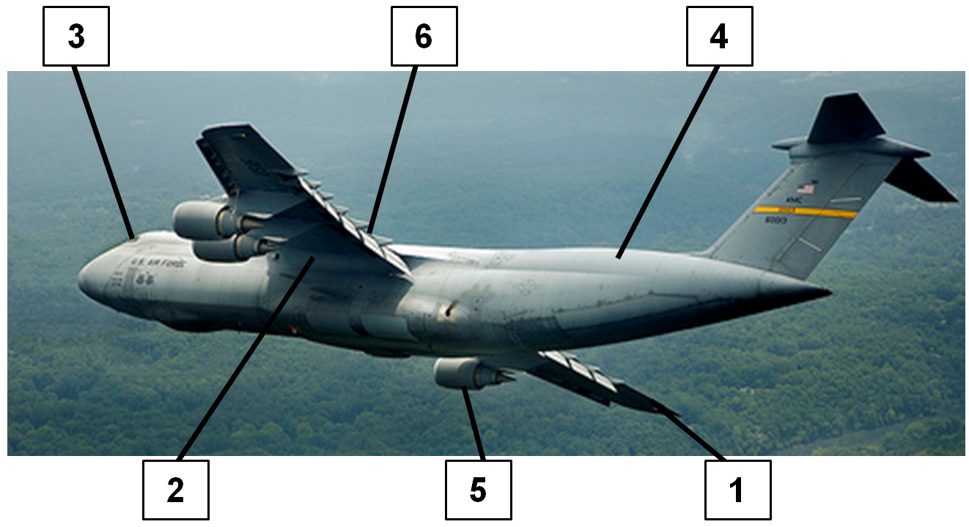 | Enter the correct labels  1. ___________________  2. ___________________  3. ___________________  4. ___________________  5. ___________________  6. ___________________

- Label the image with the following information:
  - Draw the three axes.
  - Label each axis correctly.
  - Label the correct name of the motion for each axis.
  - Label the correct motion control for each axis.
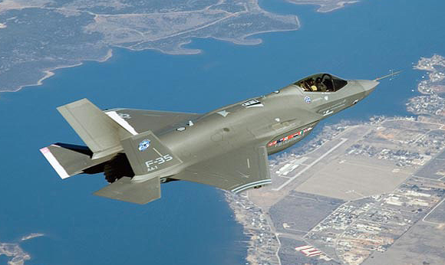

- A pilot wishes to make a descending turn to the right. Describe what position the control components will need to be in and what motions the pilot will input to make these components react.

- Describe what a flap does and where it is located on an aircraft.

Conclusion
- What aircraft have you observed that have components arranged differently or that are missing specific components?

- What improvements would impact aircraft component design?

