Activity 1.8 Instant Challenge: Paper Bridge

Introduction
Solving a problem is an amazingly creative process. Creativity can be messy. However, creativity can be channeled into a meaningful solution by using a structured design process. In this activity your team will design a solution to a problem using an engineering design process. You will document the process in your engineering notebook.

Equipment
- Engineering notebook
- Pencil
- ¾ in. wooden blocks (2)
- 1 sheet of 8 ½ x 11 in. cardstock
- Assorted construction tools such as scissors

Procedure
- Follow the direction of the teacher while completing this activity.
- Use the design process learned earlier in this lesson. Document each step in your engineering notebook.
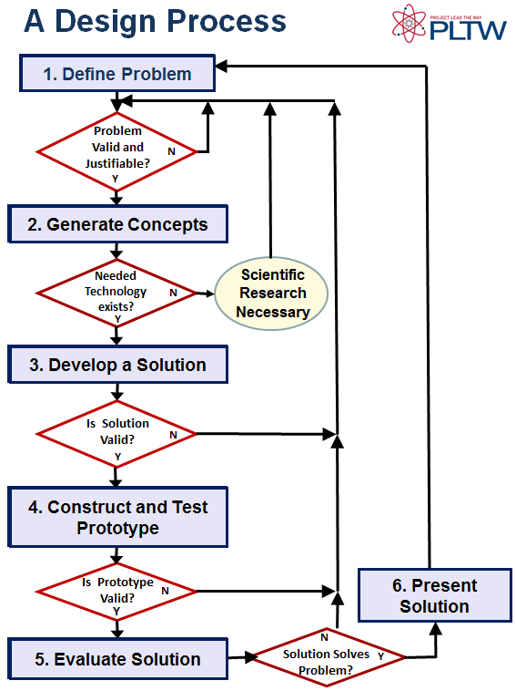
- Design and build a product that maximizes the distance between two blocks which are connected by a continuous route of paper. The product must meet the constraints below.
  - The paper must form a continuous chain of connectivity from one block to another without touching the tabletop.
  - Paper-to-paper linkage will be considered continuous.
  - The two wooden blocks are ¾ in. wooden blocks.
  - Both blocks are at table height.
  - Card stock can be modified.
  - Additional material can be used during construction, but not on the final product.
- The winning design meets the constraints above with the blocks farthest apart.

Conclusion
- Why do you think brainstorming is helpful when solving a problem?

- How did testing improve your design?

- With respect to designing the solution of a problem, what are some important characteristics of a successful team?

