Activity 1.2.9 AERY Software for Glider Design

Introduction
The AERY Glider Design Software package provides an easy to use interface for creating a glider design. The software package will perform the calculations required to predict the stability of flight for the designed glider and provide feedback on corrective actions to improve on this stability
In this activity, you will gain familiarity with the AERY software interface and glider related terminology in preparation for designing, constructing, and testing a glider.

Equipment
- PC with AERY software
- Engineering notebook
- Pencil

Procedure
- Participate in the teacher demonstration of the AERY software through active listening. Ask questions when the demonstrated technique is unclear. Record notes when you are unlikely to remember a particular technique.
- Start the AERY software loaded on your PC or using the online version at the link:http://home.comcast.net/~estenson/aery/aery.htm. The software automatically initiates a new design.

Main Interface Tab
- The Main tab is used to design the main features, in metric units, of the glider such as fuselage length, wing location, stabilizer (Horizontal) location, vertical tail (Stabilizer) location, and nose mass.
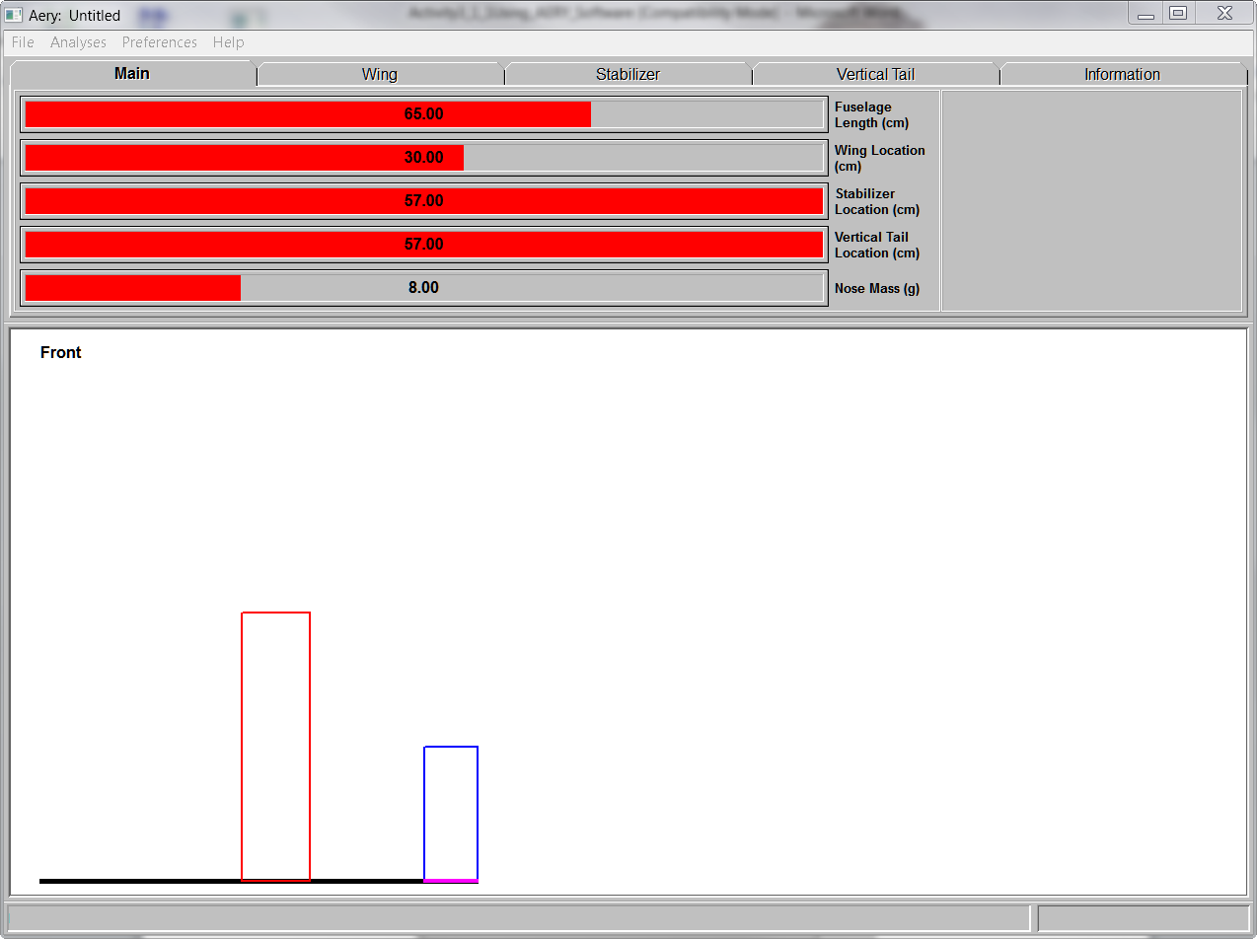

Wing Design Tab
- The majority of the lift necessary for sustained flight will be produced by the glider’s wing. The wing control panel is used to layout the wing planform by adjusting the wing Span, Root Chord, Taper Ratio, and Leading Edge Sweep Angle. This panel is used to set the approximate velocity at which the glider will be launched from the catapult that will be used during the flight testing phase of this project.
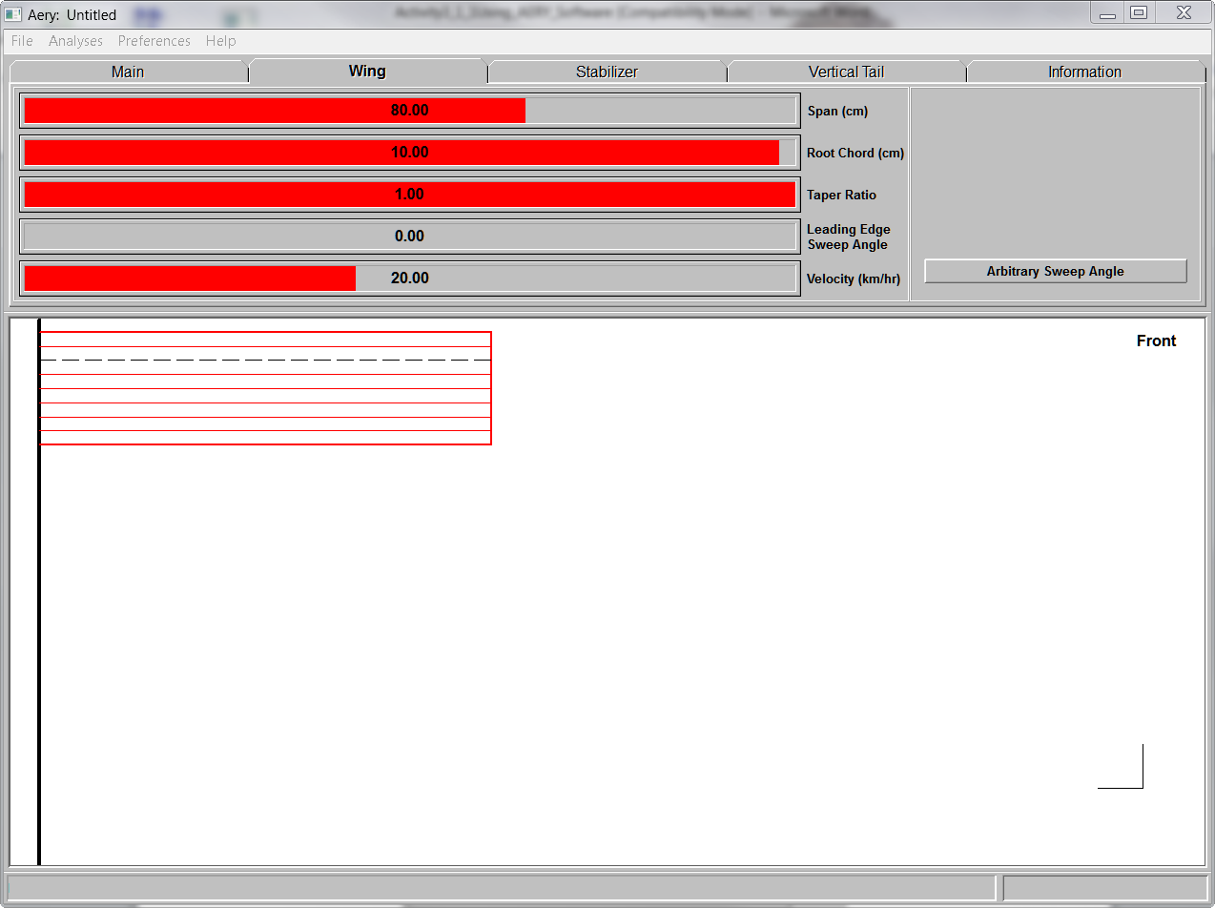

Stabilizer (Horizontal) Design Tab
- It is very challenging to design an aircraft that does not oscillate in pitch. Glider stability is improved through design of an appropriate horizontal surface. This interface is used to design the span of the stabilizer, root chord, taper ratio, and leading edge sweep angle.
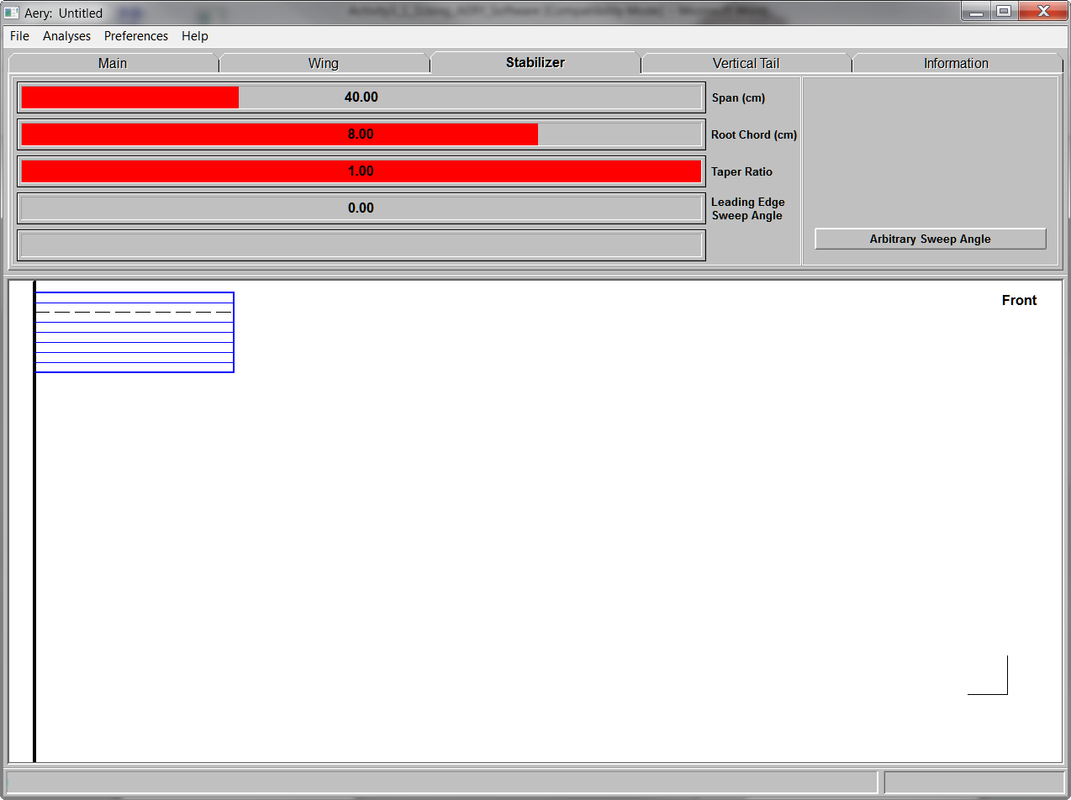

Vertical Tail Design Tab
- Aircraft can have significant directional instability causing a glider to turn left or right of a straight flight. The vertical tail creates forces that counterbalance this tendency to ensure a straight flight path. The interface allows adjustment of height, root chord, taper ratio, and leading edge sweep angle for the vertical tail of the glider.
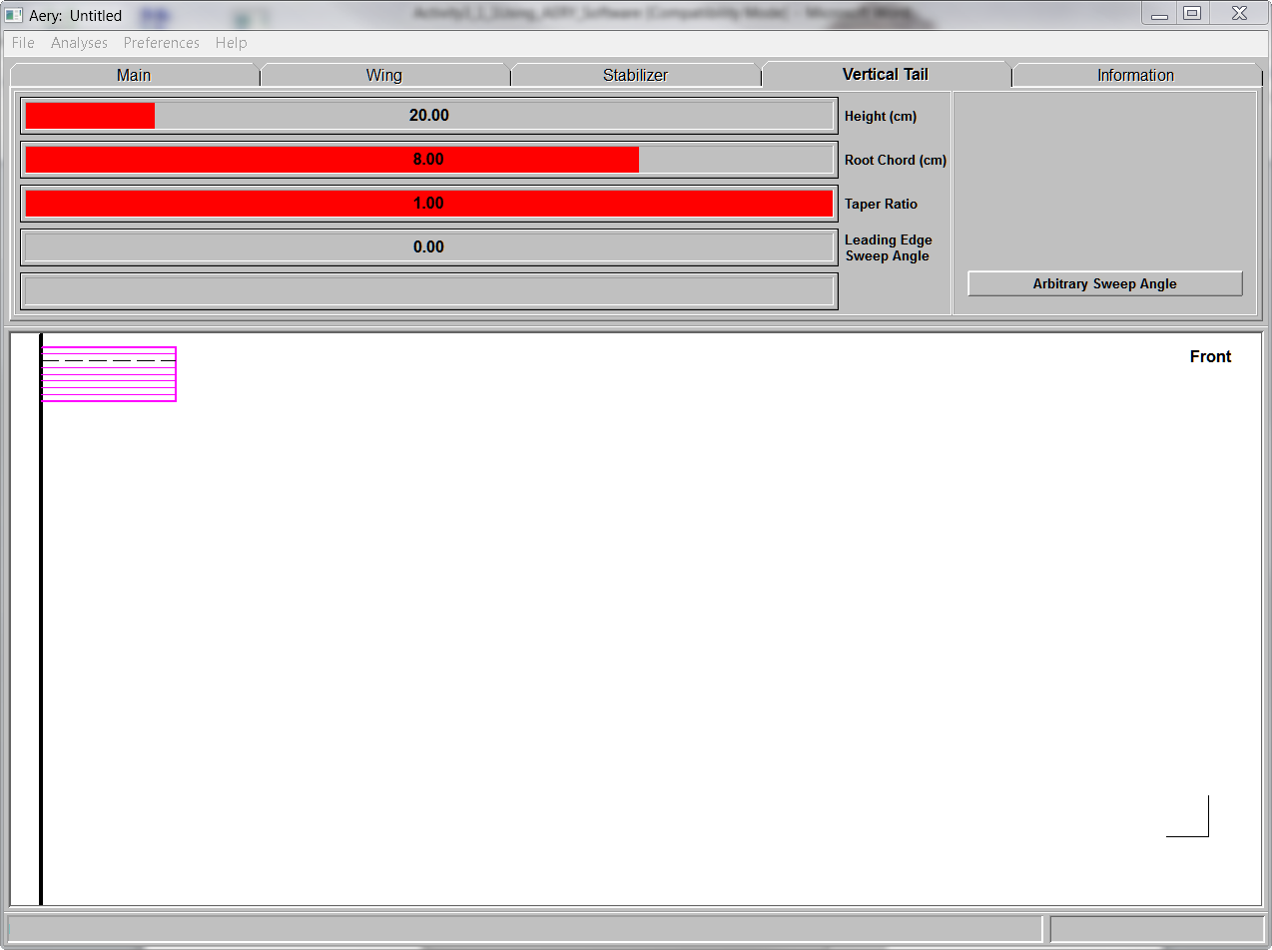

Will It Fly? Analysis
- AERY software has a powerful benefit for the glider designer through the Will It Fly analysis. The construction material characteristics selected and geometry design is used by AERY glider design software to analyze the flight stability allowing the designer to improve the design. Click Analysis then Will It Fly? to determine the stability. Clicking on the Information tab for suggested design corrects to design a stable glider.
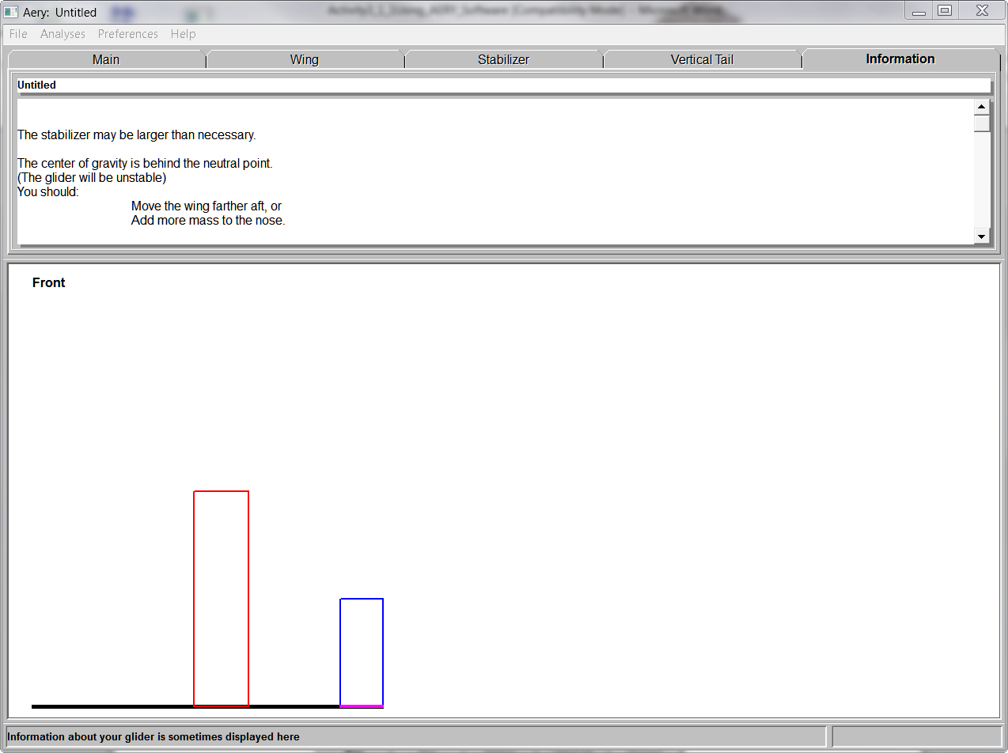

Stability Data from other Interface Tabs
- The AERY software provides detailed information regarding each aspect of the glider design. Click each tab of the interface to review data calculated by the software. This data will provide insight to the design stability. If the glider design is unstable then continue to refine the design until it is stable.

Printing Construction Plans
- Prior to printing the correct format must be selected. Click Preferences then confirm that both Use 1 Piece of Wood and Use 1:1 Scaling.
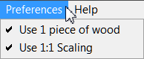

Save the Design
- Click File then Save Design, navigate to an appropriate directory and enter a file name.

Conclusion
- What are the control panel tabs? What can be adjusted on each?

- The diagram at the bottom of the screen does not look like a complete glider. What is being shown in this window? Why is this OK?

- What is the method used to manipulate your design? How do you change values, run the flight analysis function, interpret the feedback and print out a plan?

- Are you confident that you understand the AERY software features? If not, what questions need to be answered or what experiences do you need now so you will be able to complete future activities?

