Project 1.2.12 Glider Design: Long Distance Flight

Introduction
A crucial aspect of Aerospace Engineer is securing financial support for projects. This requires through planning and engineering to present a detailed proposal to potential funding agencies. The Department of Education hereby calls for proposals to provide a glider design to meet criteria provided. All submissions should have the primary design goal to be optimized for long distance, straight-line flight through a contained medium e.g. indoor flight conditions.
In this project, you will learn about the process by which projects are proposed, authorized, and proceed. You will design an original glider that sustains flight for the longest possible distance. This design challenge has requirements including time to complete an original design. Use the skills, knowledge, and understanding you have about how flight is possible. See how far you can design your glider to go!

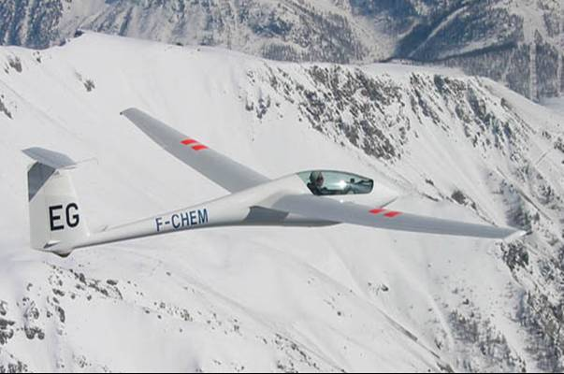

Equipment
- Engineering notebook
- Pencil
- PC with AERY glider design software
- Printer
- Project 1.2.12a Glider Design Research Funding Call for Phase One Proposals
- Project 1.2.12b Glider Design Research Funding: Research Journal Template

Procedure
Phase One Funding
Funding in phase one will secure necessary materials and resources required for the development, assembly, and testing of one prototype glider. Phase one testing will be completed under strict competitive guidelines with all designs competing under the same conditions. Successful prototypes will be required to submit a proposal for consideration for phase two funding for finalizing glider design for mass production.
Glider Design Requirements
- Sustain flight over the longest possible distance in a straight line.
- Be of original design by teams of no more than three developers.
- Utilize standard AERY software format for design development and output.
- Utilize construction materials specified by your teacher e.g. Balsa wood and adhesives.
- Have decorations that are creative and attractive.
- Be durable enough to survive normal launch, flight and landing conditions with little or no harm to its structure.
- Be able to be launched by catapult of a design specified by your teacher.

Proposal Evaluation
Prototype development work beyond the design phase must only occur after the submission of this proposal. All proposals require the approval of the Department of Education designated representative prior to transitioning to prototype construction and testing stages of development
Submission Format
All entries for consideration must use the template provided.
Submissions are due no later than: ____________ at ____________.

Procedure
- Follow your teacher’s direction to establish teams of up to three members.
- Complete the Project 1.2.12a Glider Design Research Funding Call for Phase One Proposals.
- Start the AERY glider design software.
- Edit the AERY glider design software configuration to match the construction material.
  - Click File then Edit Configuration.
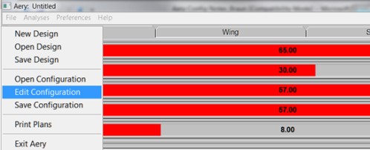

  - Enter the configuration data. The Configuration Filename must be seven characters or less. A class average for the material can be determined by weighing 10 samples and calculating the average to use in the Calculate Wing Density function. A similar averaging technique for the Calculate Fuselage Mass / Length. An example is shown below.
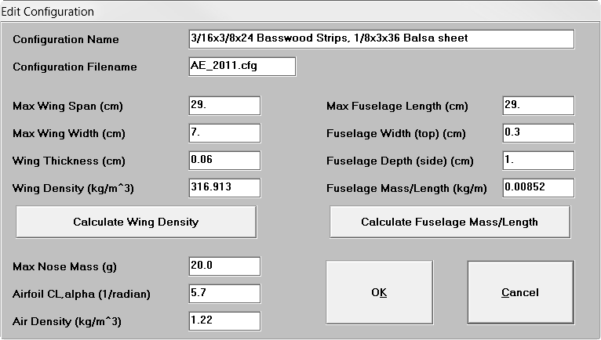
  - Click File then Save Configuration in the same folder as the AREY software. The Configuration Filename must be seven characters or less.
- Click File then New Design.
- Click File then Open Configuration. Select the file created earlier.
- Create a glider design that meets the description provided.
- At the end of each work session, document what tasks you have completed and the design developments in your Engineering Notebook using Project 1.2.12b Glider Design Research Funding: Research Journal Template as a guide.
- After completing your teams design, print copies of the design for all class members and your teacher.

Conclusion

- Funding for a new project is always limited in some way. How does the proposal process ensure that the idea being proposed will satisfy the project requirements?

- Projects fail not due to a lack of solid designs but instead due to other issues. Describe these issues and explain how the proposal process ensures that the design with the highest likelihood of success can be selected.

- Describe the most persuasive elements of your proposal.

- Explain why someone would have either a positive or negative impression after reading through your proposal for the first time.

