Principles of Engineering: EOC Study Guide
Name:_________________________________
Date:_____________________ Hr.____________
50 bonus points Completed and turned in on Day of EOC – Answers will be checked (math calculations will be evaluated on their use of the formula, work, and units)

Unit 1.1 Mechanisms– 7%
- Why must efficiency be calculated and understood during the design process?

- Match the following words with their definition:

_____ Actual Mechanical Advantage

_____ Ideal Mechanical Advantage

_____ Effort Force

_____ Resistance Force

_____ Static Equilibrium

_____ Efficiency

_____ ABET

_____ Career

_____ Mechanism

_____ Technical Communication

_____ Simple Machine

- The ratio of the magnitude of the resistance and effort forces applied to a system.
- Ratio of distance traveled by the applied effort and resistance force within a system.

- An external force applied to an object.

- Impeding effect exerted by one material object on another.

- A condition where there are no net external forces acting upon a particle or rigid body and the body remains at rest or continues at a constant velocity.

- The ratio of useful energy output to the total energy input, or the percentage of the work input that is converted to work output.

- The recognized accreditor for college and university programs in applied science, computing, engineering, and technology.

- A profession for which one trains and which is undertaken as a permanent calling.

- The structure of or the relationship of the parts in a machine, or in a construction or process comparable to a machine.

- Creating, designing, and transmitting technical information so that people can understand it easily and use it safely, effectively, and efficiently.

- Any of various elementary mechanisms including the lever, the wheel and axle, the pulley, the inclined plane, the wedge, and the screw.

- Match the following words with their definition:

____ Belt

____ Chain

____ Friction

____ Fulcrum

____ Gear

____ Idler Gear

____ Inclined Plane

____ Lever

____ Moment

____ Pitch

____ Pulley

____ Screw

____ Sprocket

____ Torque

____ Wedge

____ Wheel and Axle

____Fixed Pulley

____Moveable Pulley

- 2nd class lever with an IMA of 2. The Force directions stay constant

- A device that tapers to a thin edge and is used for splitting, raising heavy bodies, or for tightening by being driven into something.
- A continuous band of tough flexible material used to transmit motion and power within a pulley system.

- A series of usually metal links or rings connected to or fitted into one another and used to transmit motion and power within a sprocket system.

- A type of lever that is a wheel with a groove in its rim, which is used to change the direction or multiply a force exerted by a rope or cable.
- The resistance that one surface or object encounters when moving over another.

- A force that produces or tends to produce rotation or torsion.

- 1st class lever with an IMA of 1. It Changes the direction of force

- The fixed point around which a lever rotates.

- A circular toothed object used to transfer rotary motion and torque through interlocking teeth.
- A gear positioned between the driver and the driven gear used to change rotational direction.
- A toothed wheel whose teeth engage the links of a chain.

- Distance between adjacent threads in a screw.

- An inclined plane wrapped around a cylinder, forming the path and pitch

- Two different sized circular objects that are attached together and turn as one.

- The turning effect of a force about a point equal to the magnitude of the force times the perpendicular distance from the point to the line of action from the force.
- A rigid bar used to exert a pressure or sustain a weight at one point of its length by the application of a force at a second and turning at a third on a fulcrum.

- A flat surface set at an angle or an incline with no moving parts that is able to lift objects by pushing or pulling the load.

- Calculations Formulas

Work = ___________________________

AMA = (Actual Mechanical Advantage) ___________________________

IMA = (Ideal Mechanical Advantage) ____________________________

Total MA in a system: ___________________________________

Pulley IMA = _________________________________________

Moment = ______________________________

Efficiency = _______________________________

Gear Ratio = ________________________________

- Identify the type of Lever

Type - __________ Type - __________ Type - __________

MA is ___________ MA is ___________ MA is ___________

- Calculate the Static Equilibrium, the IMA and AMA for the following Lever.
Show all the formula, work, answers and units.
5ft
8ft
25lbs
EF

- Calculate the Static Equilibrium, the IMA and AMA for the following Wheel and Axel. Show all the formula, work, answers and units.
50lbs

O ?in
O 6in
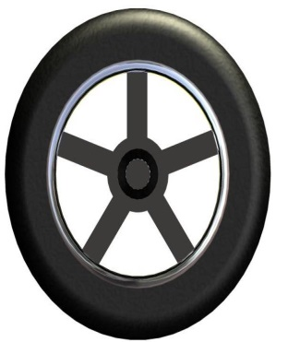

75lbs

- Calculate the IMA, AMA, and Efficiency for the following Pulley system. Fill in the amounts of pounds of force on each cable. Show all the formula, work, answers and units.

120 lbf
____ lbf

____ lbf

____ lbf

____ lbf

____ lbf

____ lbf

- Calculate the Gear Ratios for the following Gear Train. Show all the formula, work, answers and units.
Variables to know for determining Gear Ratios
n = number of teeth
d = diameter
w = angular velocity (speed)
t = torque
- MA used only to calculate forces, not torques.
- GR used only to calculate torques, not forces.

** Subscripts in and out are used to distinguish between gears **

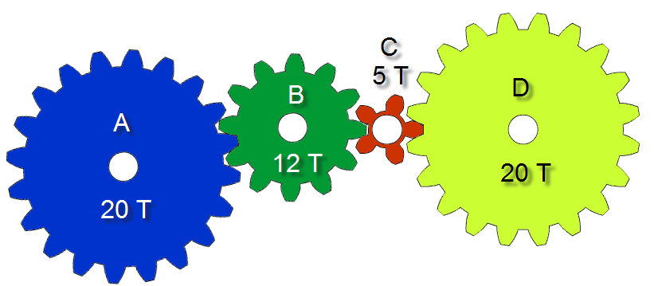
40T
15 T
50T

- What is the gear ratio between gear A and B?

- What is the gear ratio between gear B and C?

- What is the gear ratio between gear C and D?

- What is the Total gear ratio for this gear train?

- Calculate the MA for Mechanism #1 (Lever & Gear), Gear Train, Mechanism #2 (Lever and Gear), total MA for the system and total Gear Ratio of the system. Show all the formula, work, answers and units.
MA Mechanism #1…………
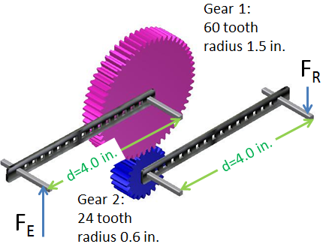
Gear 1: 50 T and 2in radius

Gear 2: 12 T and 0.5 in radius

Gear Ratio #2…………………

MA Mechanism #3 ……….

- Calculate the Gear Ratio for the entire Compound Gear Train. Show all the formula, work, answers and units.

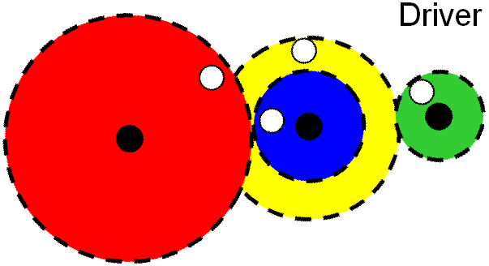
60T
40T

30T

20T

- Calculate the Torque for the Pulley and Belt System. Show all the formula, work, answers and units.

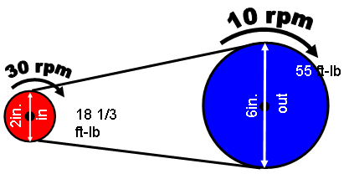
____
20

____ lbf
125ft-lbs

- Calculate the IMA, AMA, and Efficiency for the following Incline Plane where L = 12ft, H = 4ft, Effort = 25lbf and Load is 75lbf. Show all the formula, work, answers and units.

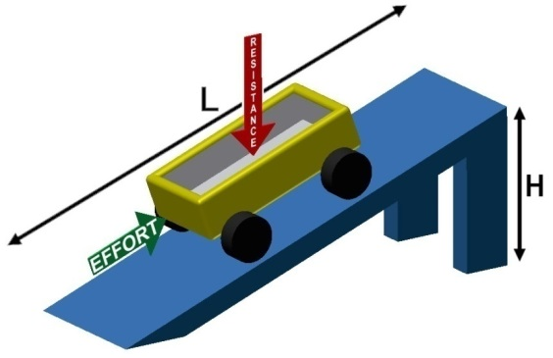

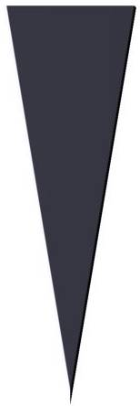
- Calculate the IMA, AMA, and Efficiency for the following Wedge where L = 8 in H = 3in, Effort = 200lbf and Load is 500lbf. Show all the formula, work, answers and units.
200lbf
500lbf

200lbf

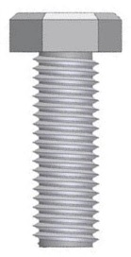
1/4 20 NC

750lbf
20T
45lbf
10T
15”

- Calculate the IMA, AMA, and Efficiency for the above Screw. Show all the formula, work, answers and units.

Unit 1.2 Energy Sources– 14%

- Match the following words with their definition:

____ Alternative Energy

____ Energy

____ Electrical Energy

____ Energy Conversion

____ Gravitational Energy

____ Environmental

____ Renewable Energy

____ Potential Energy

____ Protection Agency

____ Geothermal Energy

____ Inexhaustible Energy

____ Kinetic Energy

____ Nonrenewable Energy

____ Power Converter

- A fundamental entity of nature that is transferred between parts of a system in the production of physical change within the system and usually regarded as the capacity for doing work.
- Changing one form of energy to another.
- An energy source that will never run out.
- Energy which a body possesses by virtue of being in motion.
- The energy that a piece of matter has because of its position or nature or because of the arrangement of parts.
- A resource that can be replaced when needed.
- Energy caused by the movement of electrons.
- The use of heat from within the Earth or from the atmosphere near oceans.
- Changes one form of power to another.
- Any source of energy other than fossil fuels that is used for constructive purposes.
- An organization that works to develop and enforce regulations that implement environmental laws enacted by Congress.
- The state when objects are not yet in motion.
- A resource that cannot be replaced once used.

- Electricity at the atomic level includes Positively charged ______________, Negatively Charged _____________, and Uncharged ________________ particles.

- The atomic number is equal to the number of _____________ in the nucleus of an atom and is used to identify the element.

- Electron Orbitals: Orbits in which __________ move around the _________of an atom

- Valence Electrons: The _______________ ring of electrons in an atom

- Why is copper a very good conductor?

- Match the following words with their definition:

____ Ampere

____ Current

____ Electricity

____ Induction

____ Ohm

____ Ohm’s Law

____ Parallel Circuit

____ Series Circuit

____ Resistance

____ Volt

____ Voltage

- A circuit in which all parts are connected end to end to provide a single path of current.
- The net transfer of electric charge (electron movement along a path) per unit of time.
- The production of an electric or magnetic state by the proximity (without contact) of an electrified or magnetized body.
- The unit of potential difference symbolized as V.
- States that the direct current flowing in an electric circuit is directly proportional to the voltage applied to the circuit.
- The unit of electric current in the meter-kilogram-second system of units. Referred to as amp and symbolized as A.
- The potential difference measured in volts. The amount of work to be done to move a charge from one point to another along an electric circuit.
- A closed electrical circuit in which the current is divided into two or more paths and then returns via a common path to complete the circuit.
- The opposition that a device or material offers to the flow of direct current.
- The flow of electrical power or charge.
- The unit of electric resistance in the meter-kilogram-second system of units. Symbolized as Ω.

- Match the following words with their definition:

____ Biomass

____ Efficiency

____ Fossil Fuel

____ Generator

____ Power Grid

____ Work

____ Turbine

____ Rotor
____ Power
- A natural fuel such as coal or gas, formed in the geological past from the remains of living organisms.
- A dynamo or similar machine for converting mechanical energy into electricity.
- The rotating member of an electrical machine.
- A system that links electricity produced in power stations to deliver it to where it is needed.
- The rate at which work is performed or energy is expended.
- A result of a force moving an object a certain distance.
- Plant materials and animal waste used especially as a source of fuel.
- A machine for producing power in which a wheel or rotor is made to revolve by a fast-moving flow of water, steam, gas, or air.
- The ratio of the useful energy delivered by a dynamic system to the energy supplied to it.

- A Multimeter is used to _________, ____________, and ____________ in an electrical circuit.

- To measure Amperage, how must the meter must be place in the circuit and with the power on or off?

- To measure Voltage, how must the meter must be place in the circuit and with the power on or off?

- To measure Resistance, how must the meter must be place in the circuit and with the power on or off?

- Using OHMs Law determining the missing element in the Series Circuit. Show formula, work, answer and units. Note: you must use the following formula to calculate the total Resistance in a Series circuit first. R₁+ R₂ +R₃+R₄ = RT

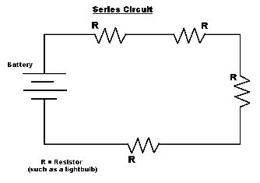

R1 = 100Ω, R2 = 10Ω, R3 = 220Ω, R4 = 120Ω
Battery = 9volts
Current = _________________

- Using OHMs Law determining the missing element in the Series Circuit. Show formula, work, answer and units. Note: you must use the following formula to calculate the total Resistance in a Series circuit first. R₁+ R₂ +R₃+R₄ = RT

R1 = 100Ω, R2 = 20Ω, R3 = 470Ω, R4 = 220Ω
Battery =_________________
Current = .02 amps

- Using OHMs Law determining the missing element in the Series Circuit. Show formula, work, answer and units. Note: you must use the following formula to calculate the total Resistance in a Series circuit first. R₁+ R₂ +R₃+R₄ = RT

RT= _________________
Battery = 6 Volts
Current = .05 amps

- Using OHMs Law determining the missing element in the Parallel Circuit. Show formula, work, answer and units. Note: you must use the following formula to calculate the total Resistance in a parallel circuit first.
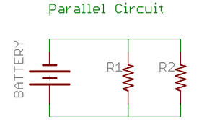

R1 = 100Ω, R2 = 120Ω,
Battery =_________________
Current = .02 amps

- Using OHMs Law determining the missing element in the Parallel Circuit. Show formula, work, answer and units. Note: you must use the following formula to calculate the total Resistance in a parallel circuit first.

R1 = 100Ω, R2 = 10Ω,
Battery =5 volts
Current = ______________________

- Points you need to know:

- Kirchhoff’s Voltage Law (KVL):
The sum of all voltage drops in a series circuit equals the total applied voltage
- Kirchhoff’s Current Law (KCL):
The total current in a parallel circuit equals the sum of the individual branch currents

- Explain the difference between a Series and a Parallel circuit.

- Electrical power is directly related to the amount of current and voltage within a system. Power can be calculated by: P= IV and is measured in ______________.

Unit 1.3: Energy Applications– 7%:

- Match the following words with their definition:

____ Line of Best Fit

____ Heat

____ Fuel Cell Stack

____ Electrolysis

____ U-value

____ Thermodynamic System

____ Temperature

____ R-value

____ Renewable Energy

____ Electromagnetic Energy

____ Kelvin

____ Radiation

____ Product Development Lifecycle

- A unit of absolute temperature and symbolized as K.
- A measure of thermal transmittance through a material.
- A resource that can be replaced when needed.
- A property of an object which determines the direction of heat flow when the object is placed in thermal contact with another object.
- A type of system that uses circulating pumps and fans to collect and distribute heat.
- Energy in transit due to a temperature difference between the source from which the energy is coming and a sink toward which the energy is going.
- The process separating the hydrogen-oxygen bond in water using an electrical current.
- A straight line that best represents all data points of a scatter plot. This line may pass through some, all, or none of the points displayed by the scatter plot. Also referred to as a Trend Line or Regression Line.
- The measure of resistance to heat flow.
- The process by which energy is transmitted through a medium, including empty space, as electromagnetic waves. This energy travels at the speed of light. This is also referred to as electromagnetic radiation.
- Individual fuel cells that are combined in series.
- A part of the physical world as described by its thermodynamic properties such as temperature, volume, pressure, concentration, surface tension, and viscosity.
- Energy caused by the movement of light waves.
- Stages a product goes through from concept and use to eventual withdrawal from the market place

As can be seen in the diagram, hydrogen molecules enter on the anode side of the cell, while oxygen enters on the cathode side. In a reduction reaction, the hydrogen molecule releases its electrons, which flow from the anode electrode through the external electric load to the cathode electrode. It is this flow of electrons which we observe as electricity. The hydrogen protons flow through the ion-conducting membrane to the cathode. At the cathode they combine with the oxygen molecules and the free electrons to form water. The fuel cell has electrochemically converted hydrogen and oxygen gases into electricity and water.

- Match the following words with their definition:

____ Conduction

____ Convection

____ Entropy

____ First Law of Thermodynamics

____ Second Law of Thermodynamics

____ Zeroth Law of Thermodynamics

____ Thermal Equilibrium

____ Thermodynamics

____ Active Solar Energy Collection

____ Passive Solar Energy Collection

- The study of the effects of work, heat, and energy on a system.

- The law that heat is a form of energy, and the total amount of energy of all kinds in an isolated system is constant; it is an application of the principle of conservation of energy. Also known as conservation of energy.

- Process by which, in a fluid being heated, the warmer part of the mass will rise and the cooler portions will sink.

- Systems that do not make use of any externally powered, moving parts, such as circulation pumps, to move heated water or air.

- A law that if two systems are separately found to be in thermal equilibrium with a third system, the first two systems are in thermal equilibrium with each other; that is, all three systems are at the same temperature. Also known as thermodynamic equilibrium.

- The function of the state of a thermodynamic system whose change in any differential reversible process is equal to the heat absorbed by the system from its surroundings divided by the absolute temperature of the system.

- Refers to the property of a thermodynamic system in which all parts of the system have attained a uniform temperature which is the same as that of the system’s surroundings

- A general statement of the idea that there is a preferred direction for any process

- A student travels on a school bus in the middle of winter from home to school. The school bus temperature is 65.0° F. The student’s skin temperature is 95.4° F. Determine the net energy transfer from the student’s body during the 20.00 min ride to school due to electromagnetic radiation. Note: Skin emissivity is 0.90, and the surface area of the student is 1.75m².

- List all known values.
A = 1.50m²
e = 0.90
ϭ = 5.6696 x 10⁻⁸ w/ m² k ⁴
t = 20.00min = 1200.s
Bus temperature = 65.0° F = ___________K (must change temp to kelvin)
Skin temperature = 95.4° F = ___________K(must change temp to kelvin)

- List all unknown values.

- Select equations.

- Apply known values to equations and solve. SHOW ALL WORK AND UNITS

Unit 1.4 Design Process – 16%

- Match the following words with their definition:

___ Accuracy

___ Brainstorming

___ Consensus

___ Design Process

___ Design Statement

___ Designer

___ Decision Matrix

___ Design Brief

___ Design Modification

___ Target Consumer

- A person or group for which product or service design efforts are intended.
- A part of a design brief that challenges the designer, describes what a design solution should do without describing how to solve the problem, and identifies the degree to which the solution must be executed.
- A tool for systematically ranking alternatives according to a set of criteria
- A major or minor change in the design of an item, effected in order to correct a deficiency, to facilitate production, or to improve operational effectiveness
- The condition or quality of being true, correct, or exact; precision; exactness.
- A systematic problem-solving strategy, with criteria and constraints, used to develop many possible solutions to solve a problem or satisfy human needs and wants and to winnow (narrow) down the possible solutions to one final choice.
- A written plan that identifies a problem to be solved, its criteria, and its constraints. The design brief is used to encourage thinking of all aspects of a problem before attempting a solution.
- A group technique for solving problems, generating ideas, stimulating creative thinking, etc., by unrestrained spontaneous participation in discussion.
- A general agreement.
- A person who designs any of a variety of things. This usually implies the task of creating drawings or in some way using visual cues to organize work.

- Put into order the Design Process steps and define each step.
_____) Define Problem
_____) Construct and test Prototype
_____) Present Solution
_____) Evaluate Solution
_____) Generate Concepts
_____) Develop a Solution

- Match the following words with their definition:

___ Assembly

___ Team

___ Component

___ Constraint

___ Open-Ended

___ Pictorial Sketch

___ Problem Statement

___ Purpose

___ Sketch

___ Solid Modeling

- A type of 3D CAD modeling that represents the volume of an object, not just its lines and surfaces. This allows for analysis of the object’s mass properties.
- A group of machined or handmade parts that fit together to form a self-contained unit.
- A collection of individuals, each with his or her own expertise, brought together to benefit a common goal.
- A part of a design brief that clearly and concisely identifies a client’s or target consumer’s problem, need, or want.
- A part or element of a larger whole.
- A rough drawing representing the main features of an object or scene and often made as a preliminary study.
- Not having fixed limits; unrestricted; broad.
- The reason for which something is done or for which something exists.
- A limit to a design process. Constraints may be such things as appearance, funding, space, materials, and human capabilities.
- A sketch that shows an object’s height, width, and depth in a single view.

- Why establish Team Norms when working in a team to solve a problem?

- What are the 6 items normally found in a Design Brief?
_______________________ _______________________

_______________________ _______________________

_______________________ _______________________

- When Developing a Team what are the three steps that you must do before a problem can be solved?
  - Step One ________________________________________
  - Step Two ________________________________________
  - Step Three_______________________________________

Unit 2.1 Statics – 11%

- Match the following words with their definition:

____ Cable

____ Cross-Sectional Area

____ Newton’s First Law

____ Newton’s Second Law

____ Newton’s Third Law

____ Moment of Inertia

____ Static Equilibrium

____ Statically Indeterminate

____Translational Equilibrium

____Rotational Equilibrium

- A structure or body which is over-constrained such that there are more unknown supports than there are equations of static equilibrium
- The change of motion of the body is proportional to the net force imposed on the body and is in the direction of the net force.
- A surface or shape exposed by making a straight cut through something at right angles to the axis.
- The state in which the sum of all the clockwise moments equals the sum of all the counterclockwise moments about a pivot point
- A strong rope, usually made of metal, designed to have great tensile strength and to be used in structures.
- If one body exerts a force on a second body, then the second body exerts a force on the first body which is equal in magnitude, opposite in direction, and collinear.
- Every body or particle continues at a state of rest or uniform motion in a straight line, unless it is compelled to change that state by forces acting upon it.
- The state in which there are no unbalanced forces acting on a body
- A mathematical property of a cross section that is concerned with a surface area and how that area is distributed about a centroidal axis.
- A condition where there are no net external forces acting upon a particle or rigid body and the body remains at rest or continues at a constant velocity.

- The _______________ _________ is the unstressed region that passes through a structural member and separates the section under tension from the part of the structural member under compression.
- The _____________ is always located on an axis of symmetry.

- Match the following words with their definition:

____ Vector Quantity

____ Scalar

____ Sense

____ Moment

____ Direction

____ Free Body
Diagram

____ Centroid

____ Resultant Force

____ Compression Force

____ Tension Force

____ Concurrent Force Systems

____ Pinned Support

____ Roller Support

____ Magnitude

____ Fixed Support

- The sense of a vector is the direction of the vector relative to its path and indicated by the location of the arrow.
- The geometric center of an area.
- A body subjected to a pull.
- The absolute value of a number.
- A support that prevents translation in any direction.
- A force system where all of the forces are applied at a common point on the body or having their lines of action with a common intersection point.
- A physical quantity that has magnitude only.
- The resultant of a system of force is the vector sum of all forces.
- A support that prevents translation and rotation in a beam.
- A quantity that has both a magnitude and direction.
- A support that only prevents a beam from translating in one direction.
- The turning effect of a force about a point equal to the magnitude of the force times the perpendicular distance from the point to the line of action from the force.
- A diagram used to isolate a body from its environment, showing all external forces acting upon it
- A body subjected to a push.
- The direction of a vector is defined by the angle between a reference axis and the arrow’s line of direction.

- Match the following words with their definition:

____ Structure

____ Simple Truss

____ Planar Truss

____ Method of Joints

____ Flange

____ Gusset

____ Joint

____ Member

- Something made up of interdependent parts in a definite pattern of organization, such as trusses, frames, or machines.
- A broad ridge or pair of ridges projecting at a right angle from the edge of a structural shape in order to strengthen or stiffen it.
- A truss composed of triangles, which will retain its shape even when removed from supports
- A method of analysis of trusses which constructs free body diagrams of each joint and determines the forces acting in that joint by considering equilibrium of the joint pin
- A plate or bracket for strengthening an angle in framework.
- Slender straight pieces of a truss connected by joints.
- The connection points of members of a truss.
- A truss that lies in a single plane often used to support roofs and bridges.

- Determine the Centroid for this figure by using the Subtraction method
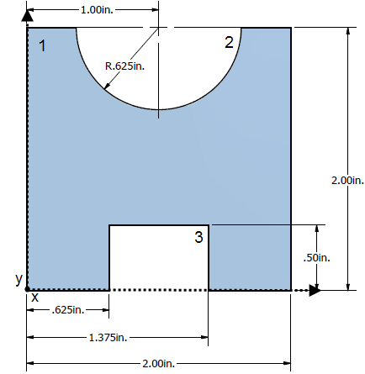

 | y_{i} | A_{i} | y_{i} A_{i}
1.
2.
3.
Total:
 | x_{i} | A_{i} | x_{i} A_{i}
1.
2.
3.
Total:

- Draw a Free body Diagram of the beam and then calculate the 12’ (W) x 4” (D) x 1.25” (H) beam’s (pictured below), Moment of Inertia and Modulus of Elasticity. Show all work, answer and units.
545 lbf

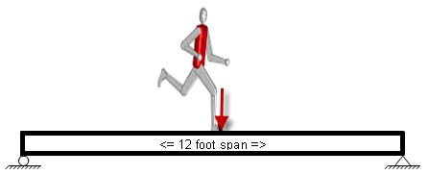
- Complete the chart below by calculating the cross-sectional area, Moment of Inertia, and Iron beam deflection, given a load of 175 lbf, a Modulus of Elasticity of 28.5 x 10⁶ psi, and a span of 12 ft. Show all work in your engineering notebook.

Common Name | 2”x8”
Actual Dimensions (in.) | 1.5” x 7.5”
Vertical or Horizontal Orientation
Cross-Sectional Area (in.²)
Moment of Inertia
(in.⁴)
Beam Deflection
(in.)

- You are walking your dog and he is pulling on the leash with 25 N and you are pull back on X Newton’s to keep him from pulling you down. You are holding the Leash at a 40 degree angle with the sidewalk and the leash is 4.5 ft long. How much force do you need to exert so the Fidos pace equals yours? Show formulas, work, answer and units. Draw a Force Diagram.

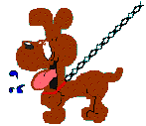

- Calculate the Truss Forces for the Below Truss. Formula, Work, Answer and Units.
Make sure to show all Angles, Reaction Forces and Internal force (compression & tension) arrows in the correct placement on the truss with the correct directions. You can use color pencils to help distinguish between forces.

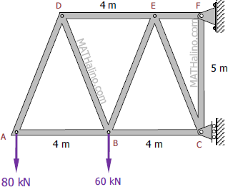

Unit 2.2 Material Properties– 9%
- Match the following words with their definition:

____ Additive Process

____ Finishing

____ Forming

____ Liability

____ Codes

____ Manufacturing

____ Mechanical Properties

____ Physical Properties

____ Subtractive

____ Product Life Cycle

____ Recycling

- Returning to an original condition. The extraction and recovery of valuable materials from scrap or other discarded materials.
- A systemized body of laws; a set of principles, as of ethics.
- Those properties of a material that reveal the elastic and inelastic reaction when force is applied, or that involve the relationship between stress and strain; for example, the modulus of elasticity, tensile strength, and fatigue limit.
- Processes that remove material to change the size, shape, or surface of a part. There are two groups of separating processes: machining and shearing.
- A process that changes the size and shape of a material by a combination of force and a shaped form.
- Properties other than mechanical properties that pertain to the physics of a material and can usually be measured without the application of force.
- Stages a product goes through from concept and use to eventual withdrawal from the marketplace.
- The process of creating an object by adding small pieces or layers together to make a final product.
- Anything for which a person is legally bound or responsible.
- Machining a surface to size with a fine feed produced in a lathe, milling machine, or grinder.
- To make into a product suitable for use; to make from raw materials by hand or by machinery; to produce according to an organized plan and with division of labor

- Match the following words with their definition:

____ Synthetic

____ Polymers

____ Raw Material

____ Metals

____ Material

____ Ceramic

____ Composite

____ Chemical Properties

____ Compounds

- Any of various opaque, fusible, ductile, and typically lustrous substances that are good conductors of electricity and heat.
- Of or relating to the manufacture of any product (as earthenware, porcelain, or brick) made essentially from a nonmetallic mineral (as clay) by firing at a high temperature.
- Produced by the combining of parts or elements to form a whole, rather than of natural origin; not real, artificial.
- The elements, constituents, or substances of which something is composed or can be made; matter that have qualities which give it individuality and by which it may be categorized.
- Crude or processed material that can be converted by manufacture, processing, or combination into a new and useful product; something with a potential for improvement, development, or elaboration.
- Solid material which is composed of two or more substances having different physical characteristics and in which each substance retains its identity while contributing desirable properties to the whole; especially, a structural material made of plastic within which a fibrous material (as silicon carbide) is embedded
- Any of numerous natural and synthetic compounds of usually high molecular weight consisting of up to millions of repeated linked units, each a relatively light and simple molecule.
- Reactivity to acid, oxygen, and flammability
- These are created when two or more elements are chemically combined

- What are the 5 common material classification categories: _________________, _______________, _________________, _______________, & _________________

- Material selection is based upon _________, required material ________, and ________.

- Describe what Distinguishing Characteristics of materials?

- How are Mixtures different from Compounds?

Unit 2.3 Material Testing– 9%

- Match the following words with their definition:

____ Axial Stress

____ Breaking Stress

____ Fatigue

____ Shear Stress

____ Stress

____ Ultimate Stress

____ Failure Point

____ Strain

____ Elastic Limit

____ Resilience

____ Stress-Strain Curve

____ Rupture Strength

- The stress required to fracture a material whether by compression, tension, or shear.
- Maximum stress that a material will withstand without permanent deformation.
- A force with its resultant passing through the centroid of a particular section and being perpendicular to the plane of the section. A force in a direction parallel to the long axis of the structure.
- Graphical representation of a material’s mechanical properties.
- Condition caused by collapse, break, or bending, so that a structure or structural element can no longer fulfill its purpose.
- The loss of the load-bearing ability of a material under repeated load application, as opposed to a single load.
- A measure of how easily a material can be twisted.
- Sometimes referred to as tensile strength; determined by measuring the maximum load a material specimen can carry when in the shape of a rectangular bar or cylindrical can.
- Nominal stress developed in a material at rupture. Not necessarily equal to ultimate strength. Since necking is not taken into account in determining rupture strength, seldom indicates true stress at rupture.
- A mechanical property of a material that shows how effective the material is absorbing mechanical energy without sustaining any permanent damage.
- The force acting across a unit area in a solid material resisting the separation, compacting, or sliding that tends to be induced by external forces.
- Change in the length of an object in some direction per unit.

- Explain what Static and Dynamic testing of a material is and why they are necessary.

- What is the Elastic Limit of a material? And what does the Yield Point have to do with it?

- Match the following words with their definition:

____ Elongation

____ Factor of Safety

____ Compression

____ Tension

____ Deformation

____ Destructive Testing

____ Nondestructive Testing

____ Variance

____ Modulus of Elasticity

____ Hooke’s Law

____ Reliability

____ Toughness

____ Proportional Limit

____ Quality Control

____ Standard Deviation

____ Statistics

- Test methods used to examine an object, material, or system causing permanent damage to its usefulness.
- The ratio of actual strength to required strength.
- The fractional increase in a material’s length due to stress in tension or thermal expansion.
- A statistical measurement of variability.
- The average of the squared differences from the mean
- The condition of a string, wire, or rod that is stretched between two points.
- The probability that a component part, equipment, or system will satisfactorily perform its intended function under given circumstances, such as environmental conditions, limitations as to operating time, and frequency an d thoroughness of maintenance for a specified period of time.
- Any alteration of shape or dimensions of a body caused by stresses, thermal expansion or contraction, chemical or metallurgical transformations, or shrinkage and expansions due to moisture change.
- The law stating that the stress of a solid is directly proportional to the strain applied to it.
- The ratio of the increment of some specified form of stress to the increment of some specified form of strain, such as Young's modulus, the bulk modulus, or the shear modulus. Also known as coefficient of elasticity, elasticity modulus, elastic modulus.
- When a material is reduced in volume by the application of pressure; the reciprocal of the bulk modulus.
- Operational techniques necessary to satisfy all quality requirements; includes process monitoring and the elimination of root causes of unsatisfactory product or service quality performance.
- Point at which the deformation is no longer directly proportional to the applied force. Hooke’s Law no longer applies.
- The collection and analysis of numerical data in large quantities.
- Test methods used to examine an object, material, or system without impairing its future usefulness.
- Mechanical property of a material that indicates the ability of the material to handle overloading before it fractures.

- What is Plastic Deformation of a material?

- What is Necking in a material?

- What is Ductility of a material? And what does Brittleness have to do with it?

- What is Toughness of a material?

Unit 3.1- Machine Control Systems– 5%

- Match the following words with their definition:

____ Algorithm

____ Analog Signal

____ Analog to Digital

____ Digital Signal

____ Digital to Analog

____ Normally Closed

____ Normally Open

____ Subroutine

____ Interface

____ Data

____ Flowchart

____ Polarity

____ Closed Loop System

____ Open Loop System

- A control system that considers the output of a system and makes adjustments based on that output.

- The contact of a relay that is closed when the coil is de-energized.

- A diagram that shows step-by-step progression through a procedure or system especially using connecting lines and a set of conventional symbols.

- Conversion of a digital signal to its analog equivalent, such as a voltage.

- A subordinate routine; specifically, a sequence of computer instructions for performing a specified task that can be used repeatedly.

- The place at which independent and often unrelated systems meet and act on or communicate with each other.

- A system of discrete states: high or low, on or off, 1 or 0.

- A signal having the characteristic of being continuous and changing smoothly over a given range, rather than switching suddenly between certain levels.

- The type of charge an atomic particle has.

- Conversion of an analog signal to a digital quantity such as binary.

- A step-by-step procedure for solving a problem or accomplishing some end, especially by a computer.

- Information encoded in a digital form, which is usually stored in an assigned address of a data memory for later use by the processor.

- A control circuit in which the system output has no effect on the control.

- Match the following words with their definition:

____ NTC Resistor

____ Transistor

____ Switch

____ Reed Switch

____ Sensor

____ Programmable Logic Controller

____ Potentiometer

____ Photocell

____ Output

____ Input

____ Feedback

____ Electromagnet

____ Microprocessor

- A device that responds to a physical stimulus (as heat, light, sound, pressure, magnetism, or a particular motion) and transmits a resulting impulse (as for measurement or operating a control).
- A switch that can provide variable motion control. It can vary the resistance within the switch, which affects both the current and voltage flowing out of the switch.
- A negative temperature coefficient, also known as a thermistor, is a sensitive resistor whose primary function is to exhibit a change in electric resistance with a change in temperature.
- A conductor wrapped around an iron core. The two ends of the conductor are attached to a power source. When current passes through the conductor, the iron core becomes magnetized.
- A solid-state switching device.
- A specialized heavy-duty computer system used for process control in factories, chemical plants, and warehouses. Closely associated with traditional relay logic. Also called a programmable controller (PC).
- Information fed into a data processing system or computer.
- A photo-sensitive resistor whose resistance decreases as the light striking the unit increases.
- A device for making, breaking, or changing the connections in an electrical circuit.
- The information produced by a computer.
- The return to the input of a part of the output of a machine, system, or process (as for producing changes in an electronic circuit that improve performance or in an automatic control device that provide self-corrective action).
- The central processing unit that is generally made from a single integrated circuit.
- An electromagnetically operated switching device.

Unit 3.2 – Fluid Power – 11%
- Match the following words with their definition:

____ Atmospheric Pressure

____ Absolute Pressure

____ Boyle’s Law

____ Charles’ Law

____ Gay-Lussac’s Law

____ Pascal’s Law

____ Pneumatics

____ Hydraulics

____ Fluid Power

- The use of gas flowing under pressure to transmit power from one location to another.

- States that the volume of a confined gas is proportional to its temperature, provided its pressure remains constant.
- The total pressure exerted on a system, including atmospheric pressure.

- The volume of a gas at constant temperature varies inversely with the pressure exerted on it.
- The absolute pressure of a confined gas is proportional to its temperature, provided its volume stays constant.

- Pressure exerted by a confined fluid acts undiminished equally in all directions.

- The pressure exerted by the weight of the atmosphere above the point of measurement.

- The use of a fluid (liquid or gas) to transmit power from one location to another.

- The use of a liquid flowing under pressure to transmit power from one location to another.

- Match the following words with their definition:

____ Check Valve

____ Volume

____ Reservoir

____ Compressor

____ Lubricator

____ Piston

____ Transmission Lines

____ Pressure

____ Pressure Regulator

____ Viscosity

____ Pressure Relief Valve
____ Receiver Tank

____ Pump

____ Valve

- The force per unit area exerted by a fluid against a surface.

- A device used to create flow in a hydraulic system.

- An air pump that compresses air into a receiver tank.

- A device used to spray an oil mist into the stream of a pneumatic system.

- The amount or quantity of something.

- Any device that controls, either automatically or manually, the flow of a fluid.

- Used to transport fluid in a circuit.

- A type of pressure control valve that limits the maximum pressure in a hydraulic or pneumatic circuit.
- A type of pneumatic pressure control valve that controls the maximum pressure in a branch of a circuit.
- A measure of a fluid’s thickness or resistance to flow.

- The tank that holds the fluid in a hydraulic system.
- A valve that allows flow in one direction but prevents flow in the opposite direction.

- A sliding piece moved by or moving against fluid pressure which usually consists of a short cylindrical body fitting within a cylindrical chamber or vessel along which it moves back and forth.
- The force per unit area exerted by a fluid against a surface

- A device that holds the compressed air in a pneumatic system.

- Match the following words with their definition:

____ Solenoid

____ Flow-Control Valve

____ Directional-Control Valve

____ Double-Acting Cylinder

____ Filter

____ Flow Velocity

____ Flow Meter

____ Flow Rate

____ Single-Acting Cylinder

____ Cylinder

____ Crank

- A part of an axle or shaft bent out at right angles, for converting reciprocal to circular motion and vice versa.

- A device used to measure flow rate.

- The volume of fluid that moves through a system in a given period of time.

- A switching device that uses the magnetic field generated by an electrical current for actuation.
- A cylinder that acts under pressure in one direction only and returns automatically when the pressure is released.

- A cylinder that can act under pressure in both directions (extend and retract) to move a load.

- Used to start and stop flow in a circuit.

- The distance the fluid travels through a system in a given period of time.

- Used to control which path fluid takes in a circuit.

- A device used to convert fluid power into mechanical power in the form of linear motion.
- A device used to remove contamination from a fluid.

- Work is calculated by multiplying Force and distance traveled. So if I have a fork lift that applies a 2000 pound force to a box of Nails and carries it 20 feet, how much work is done? Show formula, work, answer, and units.

- Power is calculated by dividing Work done by the time it takes to do the work. So in the problem above if it takes 2.5 minutes to perform the work how much Power is needed? Show formula, work, answer, and units.

- According to the slide above if there is a flow rate of 5 gpm from my garden hose under 15 psi what is the Horsepower of my garden hose?? Show formula, work, answer, and units.

- Torque is a Twisting force and can be calculated by multiplying the force by the distance traveled. So if a motor has a .75 dia. shaft and rotates at 150 rpm (revaluations per minute) what is the torque for 2 minutes? Show formula, work, answer, and units

- According to the information supplied above about Absolute Pressure, what would the Absolute Pressure of a Pneumatic system if the pressure gauge reads 115 psi? Show formula, work, answer, and units.

- According to the information supplied above about Absolute Temperature, what would the Absolute Temperature of a Pneumatic system if the temperature gauge reads 45°? Show formula, work, answer, and units.

- According to the information supplied above about Pascal’s Law, what would Pressure of a Pneumatic system that contains a 3.5” diameter cylinder with 35 lbs of force? Show formula, work, answer, and units.

- What are the 3 perfect Gas Laws and what is their purpose?

- A hydraulic lift system utilizes two 2.5 in. diameter cylinders. Workers must determine how much the system is capable of lifting before deciding how much weight can be lifted safely. The system runs at a gauge pressure of 1500 lb/in.². What is the area of each piston? How much is the system capable of lifting? Show formula, work, answer, and units.

- A 60 ft³ compressor tank container has a gauge pressure of 160 lb/in.² and a temperature of 70 °F. The temperature after some time decreases to 40 °F. Find the final pressure in the tank. Assume standard atmospheric pressure. What are the absolute temperature readings initially and after the temperature decreases? What is the absolute pressure of the system before the temperature decreases? What is the absolute pressure of the system after the temperature decreases? Show formula, work, answer, and units.

- A flow meter attached to the main line in a hydraulic system measures the flow rate at 20 gpm. The line has an inside diameter of 3 in. What is the flow velocity in the meter? Show formula, work, answer, and units.

- A hydraulic press must be used to press-fit two components together in an assembly process. The system must generate at least 775 lb of force to perform the press fit. The piston at the input cylinder is pushed with a force of 250 lb and has an area of 30 in.². The output can use up to 15 cylinders that are each 30 in.². How many cylinders are needed? What is the mechanical advantage of the system?

Unit 4.1Statistics - 5%

- Match the following words with their definition:

____ Accuracy

____ Data

____ Data Variation

____ Deviation

____ Frequency Distribution

____ Frequency Polygons

____ Event

____ Normal Distribution

____ Sample Space

- Measure of data scatter.

- A subset of a sample space.

- Listing of data values along with their corresponding frequencies

- Bell-shaped probability distribution.

- Degree of conformity of a measure to a standard value.

- A set of all possible outcomes or events in an experiment that cannot be further broken down.

- Amount of difference between a value and the mean.

- Numbers or information describing some characteristic.

- Frequency distribution graph.

- Match the following words with their definition:

____ Process Control

____ Bar Chart

____ Bayes’ Theorem

____ Experiment

____ Histogram

____ Outcome

____ Pie Chart

____ Quality Assurance

____ Statistical Process Control

____ Statistics

- An activity with observable results.

- Categorical data graph.

- Frequency distribution graph.

- SPC is a method of monitoring, controlling, and ideally improving a process through statistical analysis. Its four basic steps include measuring the process, eliminating variances in the process to make it consistent, monitoring the process, and improving the process to its best target value.

- To monitor and control a process so that the quality of the output/product improves.

- The use of quality control techniques associated with a process.

- Categorical data graph %.

- The probability of an event occurring based upon other event probabilities.

- The collection, evaluation, and interpretation of data.

- The result of an experiment.

- Match the following words with their definition:

____ Standard Deviation

____ Variance

____ Tolerance

____ Reliability

____ Probability

____ Qualitative Data

____ Quantitative Data

____ Mean

____ Median

____ Mode

____ Mean Deviation

- Values that represent a measurable quantity.

- The difference between samples.

- The square root of the variance.

- Arithmetic average.

- The calculated likelihood that a given event will occur.

- The difference between the maximum and minimum dimensions allowed within the design of a product.

- Values that possess names or labels.

- The probability of satisfactory operation of the product in a given environment over a specified time interval.

- Middle value of a set of values arranged in order of magnitude.

- Measure of variation equal to the sum of the deviations of each value from the mean

- The value that occurs most frequently.

4.2 –Kinematics - 7%

____ Speed

____ Displacement

____ Free Fall

____ Acceleration

____ Distance

____ Velocity

- A vector quantity that includes the speed and direction of an object

- The rate of change of velocity with respect to time.

- The magnitude of the total distance traveled divided by the time elapsed.

- A vector quantity giving the straight-line distance and direction from an initial position to a final position.

- The condition of unrestrained motion in a gravitational field.

- The total length of path over which the particle travels.

