Activity 1.9 Design Innovation

Introduction
Name a product or process that is truly an original invention. You possibly named an Xbox Kinect or an iPhone. These products are examples of high quality consumer products; however, neither is an invention. Both are innovations: an improvement of an existing technological product, system, or method of doing something. The Kinect is an adaptation of existing technology using multiple cameras and facial and voice recognition to interact with a computer using gestures. An iPhone adapts mobile phone technology dating back to 1973.

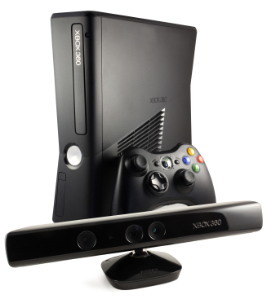

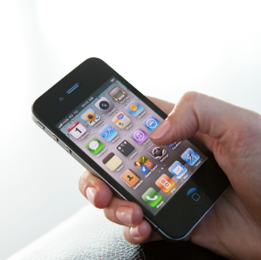 | 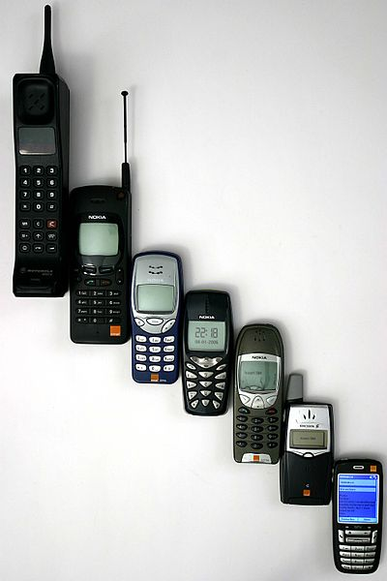

An invention is a new product, system, or process that has never existed before, created by study and experimentation. An example of an invention is a nanobot. Robots of a size comparable to atoms had not been accomplished previously. The first wheel would be an invention. The modification to make the wheel out of aluminum alloy and cover it with a synthetic rubber tire is an innovation.

In this activity your team will research an original invention and show the timeline of subsequent innovations.

Equipment
- PC with Internet access
- Engineering notebook
- Pencil

Procedure
- Form a two person team with the guidance of your teacher.
- Select an invention that your team will research. Examples are listed below, though the possibilities are numerous.
- Anti-lock brakes  - Multiplane camera  - 3D printer  - Bullet-proof glass  - Internet based social network  - Garbage disposal  - Tetracyline  - Optical fiber  - Random access memory  - Playable/recordable sound media  - Gaming control device  - Bicycle | - GPS  - Crop rotation  - Hybrid plant  - Low level laser therapy  - Cataract surgery  - Teflon  - Air conditioner  - Calculator  - Eye glasses  - Kevlar  - Coffee maker  - Elevator
Record the invention chosen by your team _________________________

Teacher approval of invention __________________

- Research the invention chosen by your team. Discover at least the information below and document in your engineering notebook.
  - When was the product invented?
  - Who invented the product?
  - List any existing patents.
  - What materials were originally used to make the product?
  - How was the product originally made?
  - What improvements have been made to the product?
  - Why were these improvements made?
  - Who uses the product?
  - What is the global impact on society of the invention and subsequent innovations?
  - If you had the ability to change this product in any way, what would you change?
- Prepare to make a three to five minute presentation to your peers on the invention and innovation. Include a minimum of the information shown below.
  - Include your team member names, class, period, and selected invention.
  - Explain the original invention and patents.
  - List the discipline(s) of engineering most important to the development of the product and explain how these disciplines were essential.
  - Provide a timeline drawn to scale showing the history of the invention and evolution.
  - Identify major changes that have occurred in the design of the product.
  - Address the global impact on society and the environment.
  - Provide a reference page of at least four Internet sites and other sources used to gather your presentation information. Record all citations in APA style.
- As a class combine research findings into a timeline drawn to scale. Each invention should be included on the timeline with a brief statement about the importance of the advancement or achievement. The timeline scale will show development pace including time lapse between achievements.

Conclusion
- Define and differentiate invention and innovation.

- What were the major factors that contributed to past innovations of the invention that you researched?

- How has the pace of development changed through the history of the design?

- What future innovations to the chosen invention do you predict?

