Activity 1.2.6 Airfoil Simulation

Introduction
Airfoils have a complex geometry designed to direct airflow. This velocity change results forces that affect aircraft performance. This can be simulated using a computer to provide an estimate of expected performance.

In this activity you will design an airfoil to meet the design criteria.

Equipment
- PC with Internet access or FoilSim III Student Version 1.4d software
- Engineering notebook
- Pencil

Procedure
- Start the PC and launch the FoilSim applet or FoilSim online version which can be found at http://www.grc.nasa.gov/WWW/K-12/airplane/foil3.html.
- Design the airfoil to achieve the results given by your teacher.
  - Use the geometry assigned by your teacher eg. symmetric, high center, flat plate, flat bottom, negative camber, ellipse or curve plate.
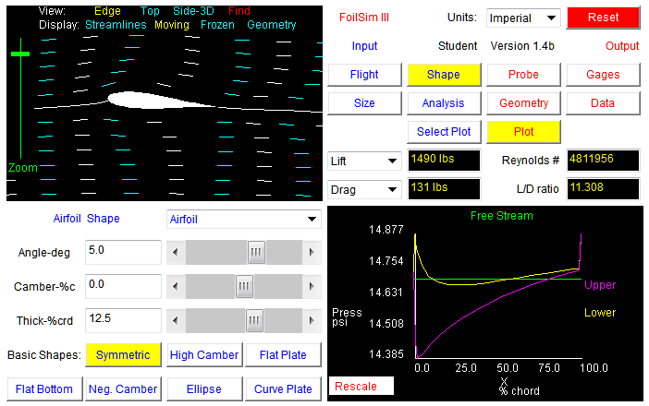
  - Change the Lift and Drag to Cl and Cd to compare results.
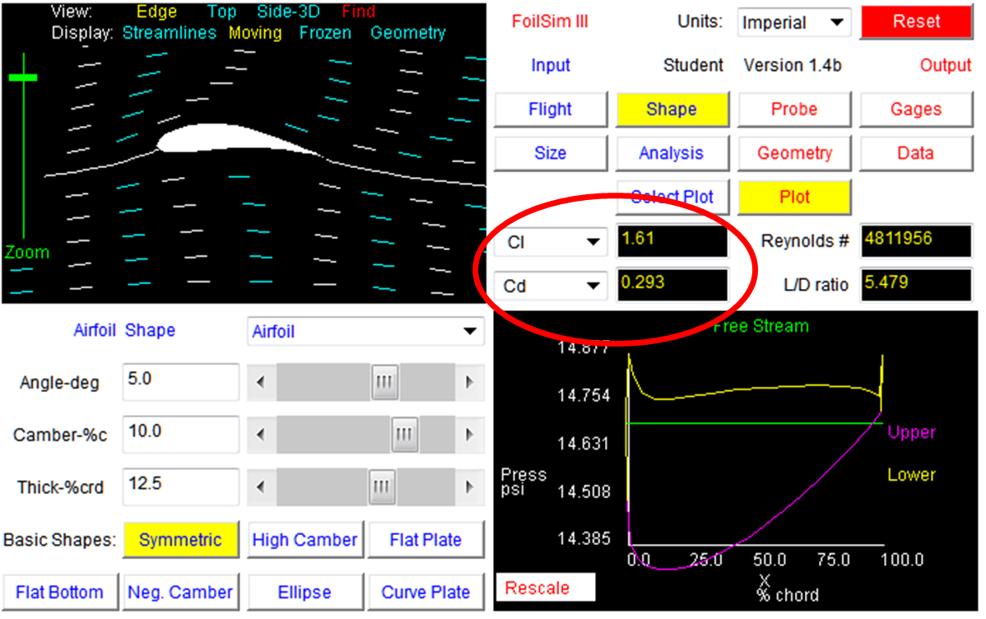

  - Your airfoil shape results can be seen graphically using the gauges button as shown below. The final quantitative results are available using the Data tab.
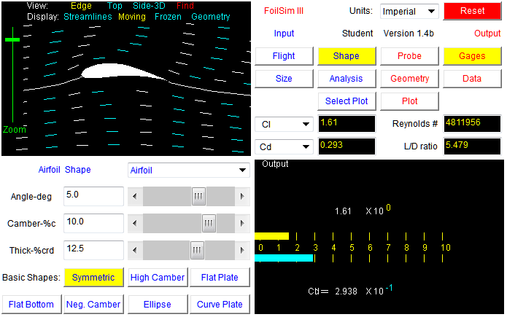

- Set the First Angle of Attack to -20^{O} and the Final Angle of Attack to 20^{O} and the Angle of Attack Step to 5^{O}. Record the C_{l} and C_{d} for each angle of attack.

Conclusion
- What parameters impact the Cl and Cd?

- Explain why these have such an impact.

