Activity 1.2.4 Atmosphere

Introduction
Our atmosphere is a fragile blanket that surrounds the Earth. This mixture of gases containing mostly Nitrogen is crucial for us to survive.

In this activity you will calculate the pressure and temperature at various altitudes.

Equipment
- PC with Internet connection
- Pencil
- Calculator
- Notes from the Atmosphere presentation

Procedure
- A F35 is flying at 1,026 kph at 8,350 m. What is the air temperature assuming a standard surface temperature of 15 ^{O}C? Show all your calculations.

- A F-22 Raptor has just climbed through an altitude of 9,874 m at 1,567 kph when a disk ruptures in a sensitive piece of optical equipment. As the engineer analyzing the failure determine the pressure differential across the sensor housing if the inside sensor pressure was 122 kPa.

- Verify your answer using the NASA AtmosModeler at http://www.grc.nasa.gov/WWW/K-12/airplane/atmosi.html. Print screen of the final output. Note that the output toggle should be changed to Data to see the precise outputs.
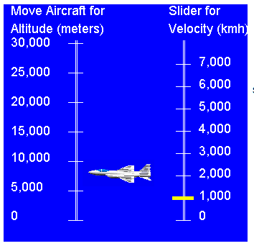
NASA AtmosModeler

Conclusion
- Explain how the temperature lapse rate will affect aircraft design.

- Explain how the pressure lapse rate will affect aircraft design.

