Activity 1.2.3 Airfoil

Introduction
Airfoils range from complex supersonic shapes to simple cloth construction. You can create a simple airfoil to see how airflow applies lift to a simple shape. In this activity you will create a simple airfoil and generate lift.

Equipment
- PC with ROBOTC Software
- Pencil
- 2 in. x 9 in. strips of paper (5 pieces)
- Airfoil completed using the Activity 1.2.3a Airfoil Construction Guide
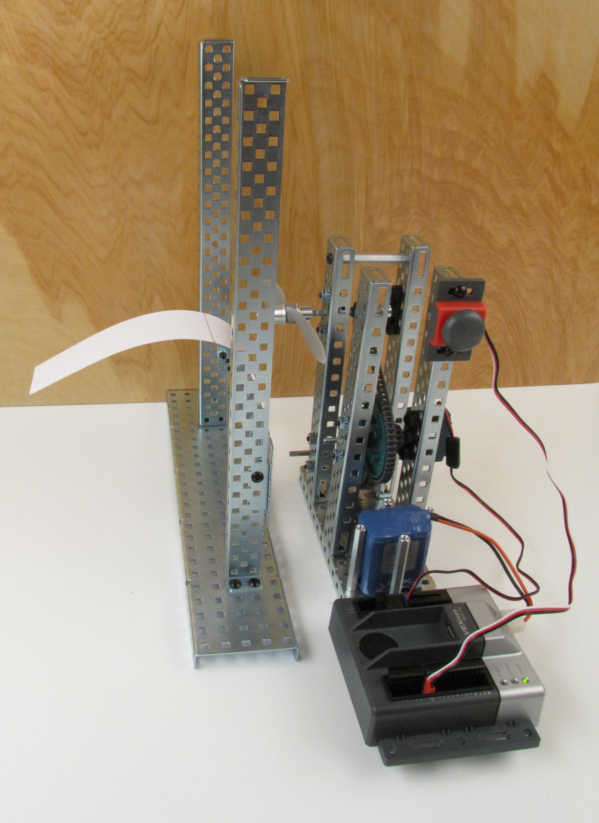

Procedure
- Form groups of four with the direction of your teacher.
- One student will hold the narrow end of a 2 in. x 9 in. strip of paper to their chin. Gently blow across the top of the paper to demonstrate to the other student how the paper raises when air flows across it. Gradually increase the intensity of the air flow to lift the strip of paper higher. Dispose of the paper strip.
- The other three students will repeat the previous step with a new strip of paper.
- Align the airfoil as shown in the Activity 1.2.3a Airfoil Construction Guide. Ensure that there is a safe gap between the propeller and the airfoil stand.
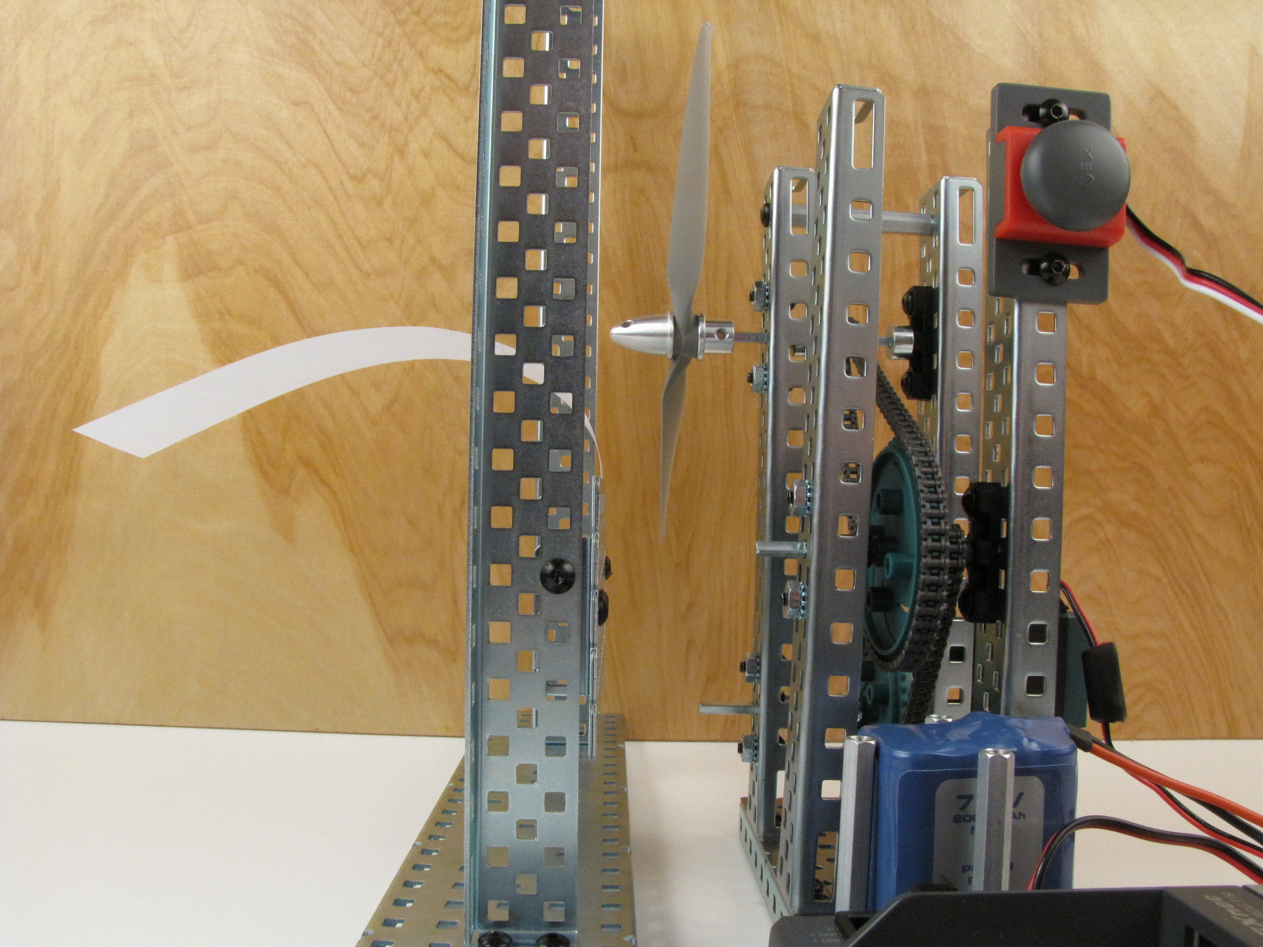
- Ensure that all objects are clear of the propeller.
- Push the bump switch.
- Record your observations in your engineering notebook.
- Add one paper clip at a time and repeat the step above.
- Record your observations in your engineering notebook.

Conclusion
- Describe why the airflow affected the paper strip.

- How could you apply this knowledge to your daily life?

