Problem 7.7A Product Improvement ALTERNATE

Introduction
When customers shop for an automobile, what are they looking for? Most customers will pay a great deal of money for a vehicle that they believe is visually appealing, structurally sound, and functioning well within a myriad of acceptable parameters. These same qualities that customers look for in their automobiles are extended to other designs such as houses, furniture, computers, sporting equipment, and clothing. The list is endless.

Having studied the history of a consumer product, you may have noticed that the innovations that took place throughout that product’s history could be categorized as either visual, structural, or functional improvements. Now that you have reverse-engineered a product and are aware of these qualities, you must ask the question, “Which of these qualities could be better?” Once you have answered this question, you will have taken your first step in the product improvement process.

Equipment
Engineering notebook
Digital camera
Graph paper
All related CAD models from your reverse-engineered product
CAD solid modeling software
Internet access
Library access
Printer
Product Improvement Design Brief Template
Decision Matrix Template

Procedure
- In this activity you and your partner will identify a need for a visual, structural, or functional improvement to the object that you have reverse-engineered. Begin the process by recording any visual, structural, or functional design issues in your engineering notebook.

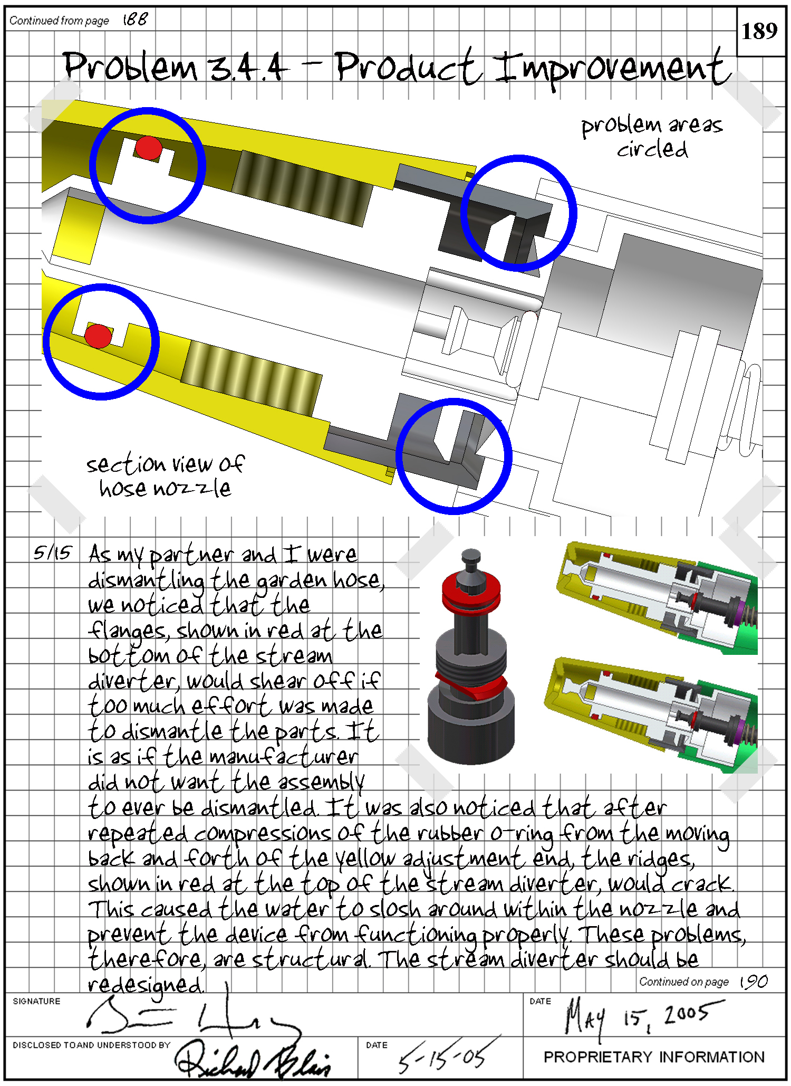

- As a team you will write a design brief that explains the problem, identifies the solution expectations and the degree to which that solution will be realized, and lists any appropriate project constraints. You and your partner will then present this design brief to the class.

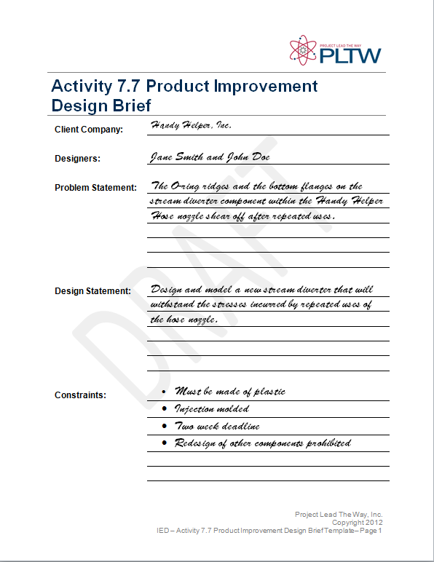

- Once all teams’ design briefs have been communicated, the class will work together as one design team to brainstorm ideas on graph paper that address each team’s problem. This will generate a critical mass of ideas that each team can use to aid them in their design process. You and your partner will then conduct whatever research may be necessary and expand on the class’s ideas by brainstorming with your partner. Narrow down the number of plausible ideas to a handful.

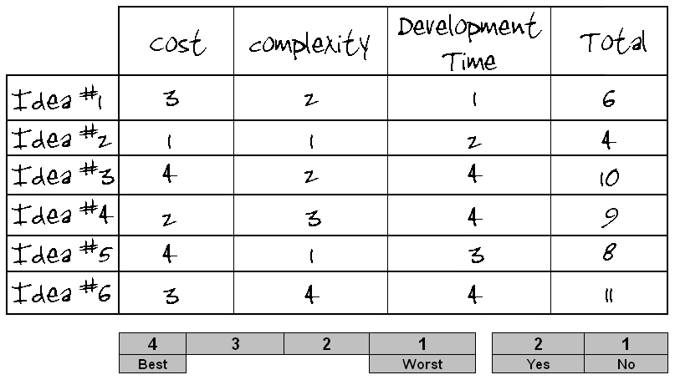

- Your team will then develop a decision matrix to help with the idea selection process. Once an idea has been selected, you and your partner will develop it into a solution using a 3D CAD solid modeling program.
- You will document the design of your design using part drawings and assembly drawings as necessary.
- Your team will present its design process and product improvement results to the teacher in the form of a technical report, which will be added to your design portfolio.

Conclusion
- What factors must be considered when changing or enhancing a design?

- Why it is important to document the brainstorming process?

- What is the purpose of sketching your ideas?

