Activity 3.4 Linear Dimensions

Purpose
If you were given the responsibility of going to a store and purchasing a throw rug that had to fit within a room in your home, how would you communicate the shape and size of the room to the salesperson?

Given the sketching skills that you’ve developed, you would probably sketch a top view of the room on a piece of paper. This would be useful, but a sketch alone only communicates shape information.

A shape has a size that must be communicated in order to make intelligent design decisions. Information about an object’s size must be conveyed using dimensions. In manufacturing, a part must be dimensioned fully and correctly and to the proper precision. Otherwise, the part may not function properly or may not fit into an assembly as intended. Dimensioning errors can lead to a delay in production time, increased design and manufacturing costs, and a potentially unsafe product.

In this activity, you will apply your knowledge of dimensioning to identify dimensioning errors and provide missing dimensions on multi-view drawings. You will also fully dimension multi-view sketches according to dimensioning guidelines.

Equipment
Number 2 pencil with eraser
Engineering notebook
Inch scale or ruler

Procedure
Identify dimensioning errors based on the Dimensioning Guidelines. Circle each error and place a letter, A through P, next to each error on the drawing. In the space provided below each drawing, next to the appropriate letter, give the reason for each correction and cite the dimensioning guideline that is misapplied.

1. Multi-view Drawing #1
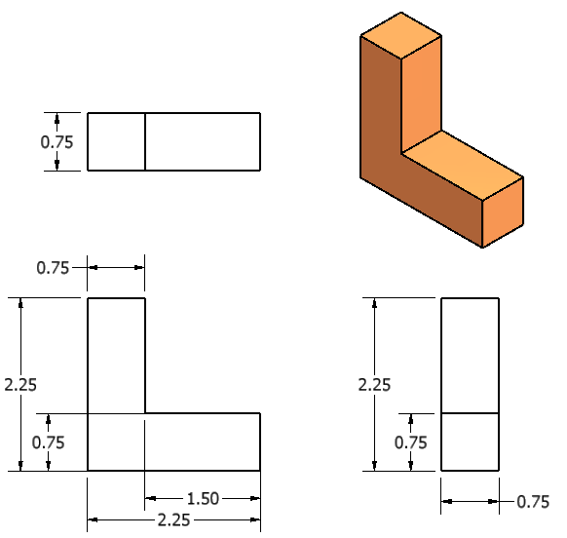

 | Dim.  Guide | Reason |  | Dim. Guide. | Reason
 | 4a  7 | Double-dimension;  wrong side

2. Multi-view Drawing #2

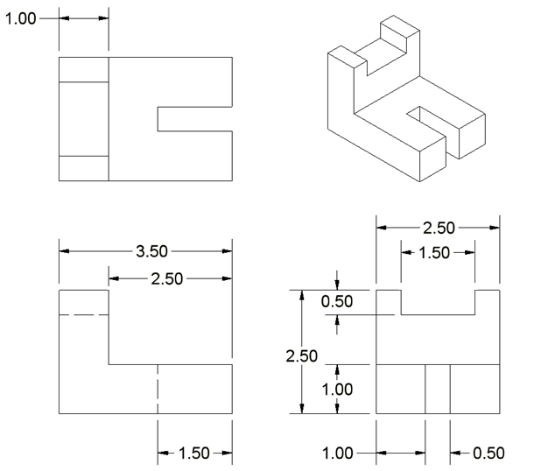

 | Dim.  Guide | Reason |  | Dim. Guide | Reason

- Multi-view Drawing #3
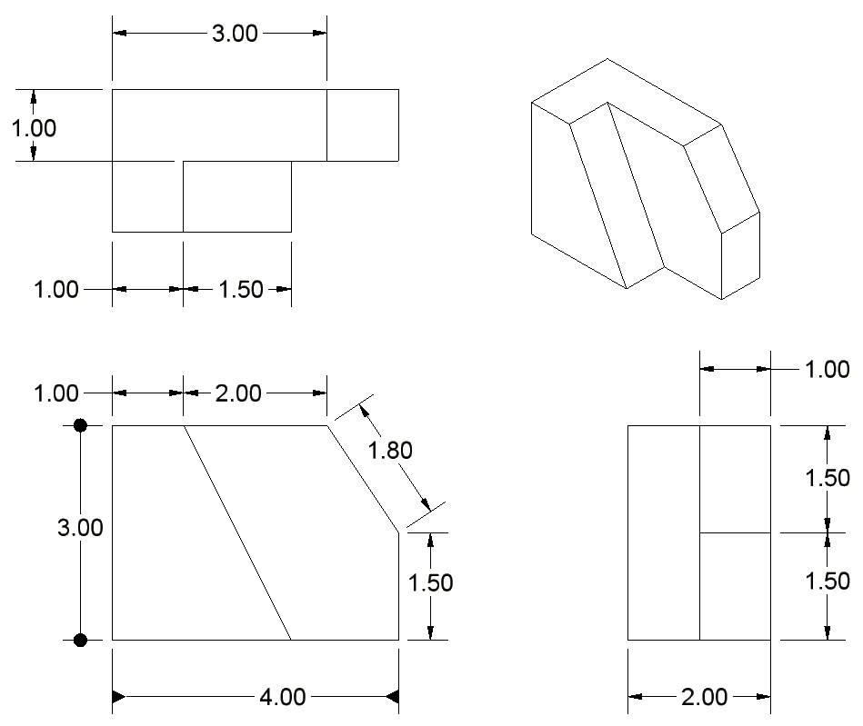
 | Dim.  Guide | Reason |  | Dim. Guide | Reason
- Multi-view Drawing #4
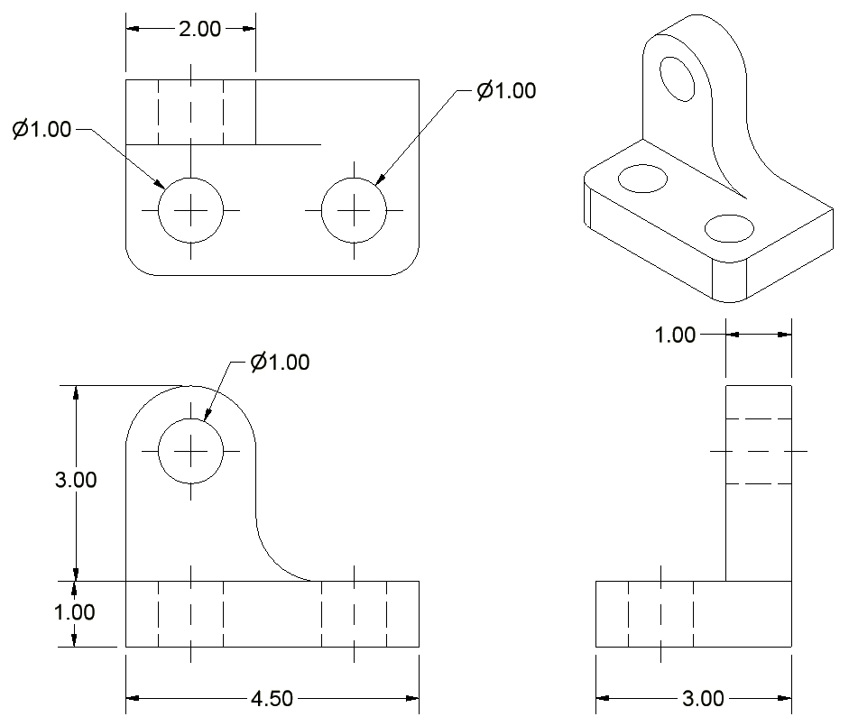
 | Dim.  Guide | Reason |  | Dim. Guide | Reason

- Sketch an isometric view of the object. Then dimension the orthographic projections. Line spacing on the grid equals 0.125 in.
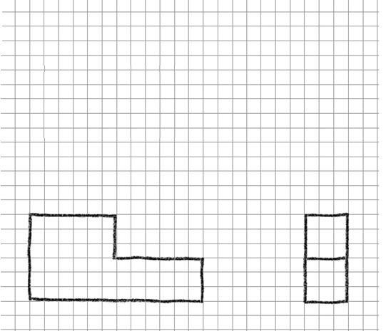

- Sketch an isometric pictorial of the object. Then dimension the orthographic projections Line spacing on the grid equals 4 mm.
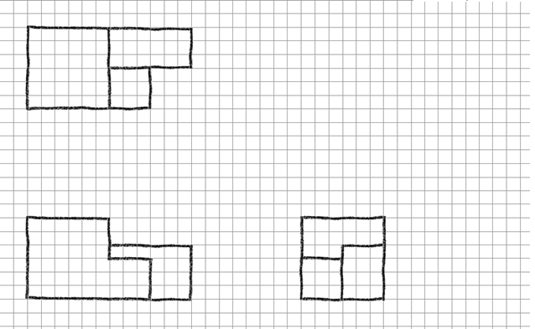

- Fully dimension the following sketch. Each square on the grid equals one cm.
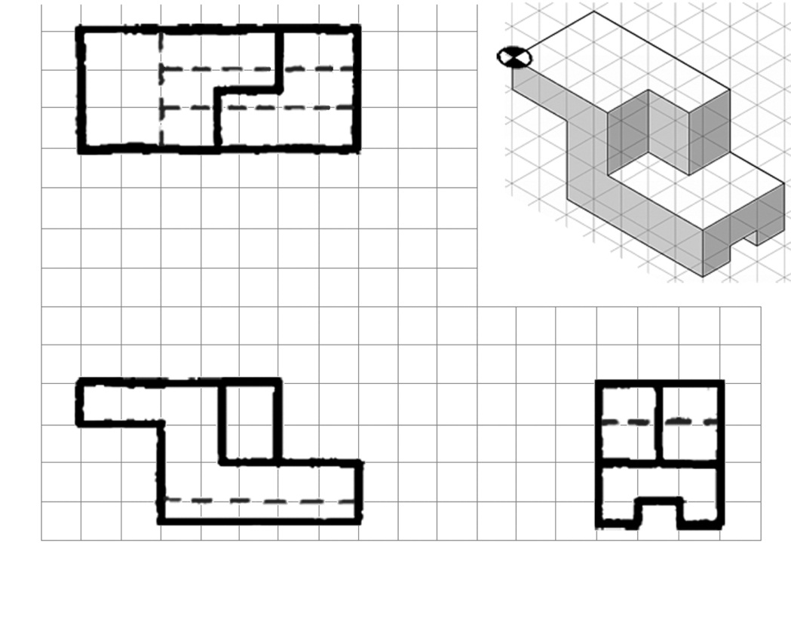
- In your notebook, create a fully dimensioned multi-view drawing for the following puzzle cube piece. Assume that the puzzle cube piece is made up of six ¾ in. cubes.
What type of pictorial is used above to represent the puzzle cube piece? How can you tell?

- Review another student’s fully dimensioned multiview drawing completed for item 8. Identify any dimensioning errors (or errors in line work, view selection, or view orientation) and record the errors on a copy of the drawing or on a separate sheet of paper. For each error, provide the following effective feedback.
    - Cite the dimensioning guideline that was misapplied (goal-reference feedback)
    - Fully describe the error (tangible and transparent feedback)
    - Provide a suggestion (or ask a question) to help the sketcher improve their work (actionable feedback)
Is your feedback constructive? Remember that constructive feedback addresses the work and not the individual. Feedback should be “tough on the content, but soft on the person”. Does your feedback focus on the sketch itself?

Extend Your Learning
- In your notebook create a fully dimensioned multi-view drawing for the part shown below. Note that you have already sketched orthographic projections in Activity 2.4 Multi-view Sketching.
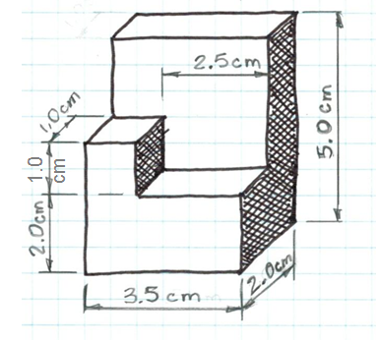
- Go back to Activity 2.4 Multi-view Sketching. Fully dimension the multi-view sketches that you created in numbers 3 through 5. Use the following grid spacing.
- For numbers 3 the grid line spacing is 0.5 cm.
- For number 4 the grid line spacing is 2 mm.
- For number 5, the grid line spacing is 0.25 in.

Conclusion
- Why is placement of your dimensions so important?

- Why do designers need to fully dimension a part?

- What does it mean when a sketch is over dimensioned?

