Activity 1.2.3 Electrical Circuits – Simulation

Introduction
Since the late 1800s, engineers have designed systems to utilize electrical energy due to its ability to be converted, stored, transmitted, and reconverted efficiently into other forms of energy. In the 21st century, electrical energy production, distribution, and application have become consumer driven. Today’s consumer utilizes electrical energy in all aspects of life, from cell phones and computers to refrigeration and heating and cooling systems, and even transportation. Electrical energy, depending on geographic location, is converted from mechanical energy, chemical energy, light energy, and thermo energy before it reaches the consumer.

Regardless of the conversion process, electrical energy consists of three basic components: current, voltage, and resistance. Current is the net transfer of electric charge per unit of time. Voltage is the amount of work required to move a charge from one point to another. Resistance is the opposition to the flow of current. Understanding the relationship between current, voltage, and resistance allows engineers to design efficient, safe, and functional electrical circuits. Electrical circuits consist of the following components: an energy source to provide voltage, conductors to allow current travel, insulators to limit current travel, and a load. Electrical circuits provide an uninterrupted path for current travel and are broken into two distinct categories of design: series circuits and parallel circuits.

Equipment
- Engineering notebook
- Calculator
- PC with Internet (http://phet.colorado.edu/en/simulation/circuit-construction-kit-dc)
- Simulation courtesy of:
  - PhET Interactive Simulations
University of Colorado
http://phet.colorado.edu.
Procedure
This activity will provide you with an introduction to voltage, current, resistance, series circuits, parallel circuits, and Ohm’s Law. Your team will construct circuits using an online electricity simulator. You will use a virtual multimeter to measure properties within the circuit.
Introduction to Electric Circuits
Electric Circuit Schematics
Schematics are diagrams consisting of symbol representations and configurations of electrical components within a circuit. The table below illustrates circuit symbols to be used within schematics throughout this lab.

Component | Symbol | Pictorial
Power supply  (Battery) | 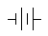 | 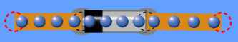
Conductive wire |  | 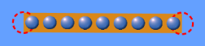
Resistor |  | 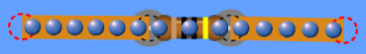
Open switch  Closed switch | 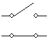 | 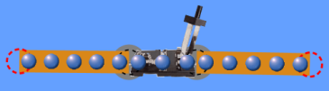  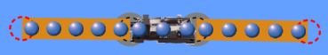
Light bulb |  | 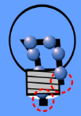
Voltmeter  (Voltage readings)  V | 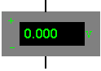 | 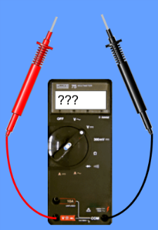
Ammeter  (Current readings)  I | 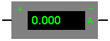 | 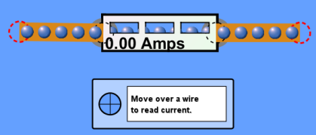

Ohm’s Law
The relationship between current, voltage, and resistance within an electrical circuit was developed by Georg Simon Ohm and is known today as Ohm’s law. Ohm’s law states that the direct current flowing in an electric circuit is directly proportional to the voltage applied to the circuit. In other words, an electric circuit represents the flow of electrons along a conductive pathway between two points. This flow of electrons is referred to as current. What causes the electrons to move? A motivation, or voltage, causes the electrons to flow. Voltage refers to the potential difference, or amount of work to be done to move a charge from one point to another along an electric circuit. While electrons continuously flow along a given circuit, opposition to their movement is referred to as resistance.

It is important to understand the mathematical equation for Ohm’s law. Use the Ohm’s law table provided to work through activity practice problems and lab calculations.
Ohm’s Law
Equation | Variables | Units | Unit Symbols
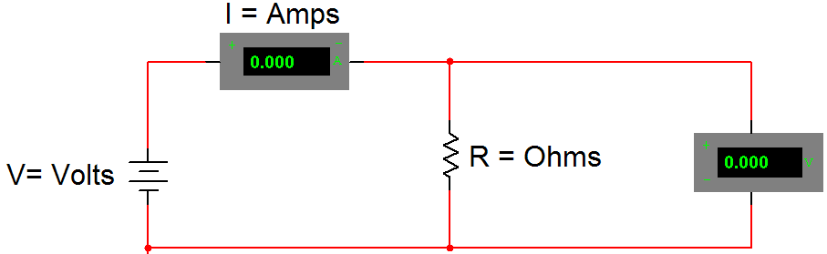

Practice Calculations
Draw the circuit schematic.
Identify the known and unknown values for each circuit.
Provide the appropriate unit for each measurement.
Show all steps for each calculation.

- On a camping trip, you decide to use a cordless air pump to inflate an inflatable mattress. If the air pump is powered by a 9 volt battery with a resistance of 18 ohms, what is the amount of current flowing through the circuit?
Circuit Schematic | Calculations

- A DJ uses a 110 volt outlet to plug in a strobe light. If the current flowing through the light is 0.050 amps, how much resistance is within the circuit?
Circuit Schematic | Calculations

- You finally found the MP3 player that you have wanted for months. While you are waiting in the check-out line, you read the back of the packaging. The manufacturer has guaranteed that the player will perform consistently with a resistance of 40 ohms and a current of 0.1 amps. What is the voltage for the MP3 player?
Circuit Schematic | Calculations

Constructing Circuits
Your team will construct a series and parallel circuit using the steps provided below.
Creating a Circuit
- Launch Circuit Construction Kit from University of Colorado at Boulder: http://phet.colorado.edu/en/simulation/circuit-construction-kit-dc
- Drag a battery from the circuit palate on the right. R-click on the battery and set the voltage to 9 volts.

- Construct the circuit displayed below using the default bulb and a switch in the open position. Note that your circuit will not look like the image below. You are to interpret the schematic diagram to create a circuit. Check the voltage across the light bulb. Record the measurements in the space provided below.

NOTE: When measuring voltage getting a positive or negative value is dependent upon polarity or direction of flow. In other words, the 4.5V and -4.5V could be taken from the same source depending on placement of the leads.
Voltage across bulb _______V | 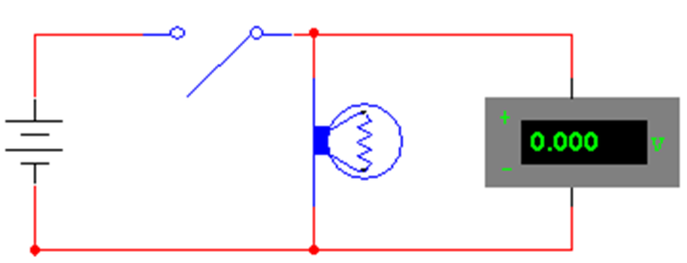
- Close the switch so the bulb remains on. Obtain the voltage measurements across the bulb and the power supply. Record the measurements in the space provided below.
Bulb _______V Power supply __________V

- Check the current through the light bulb by adding an ammeter. Record the measurements in the space provided below.
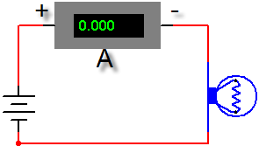 | Current _____________A
- Use the voltage (V) and current that you have already determined for this circuit current (I) to determine the resistance of the bulb. Show your work and include units.
Formula:

Substitute values:

Solve:

Resistance = _______________Ω

Creating a Series Circuit
- Use the image below to create a series circuit.
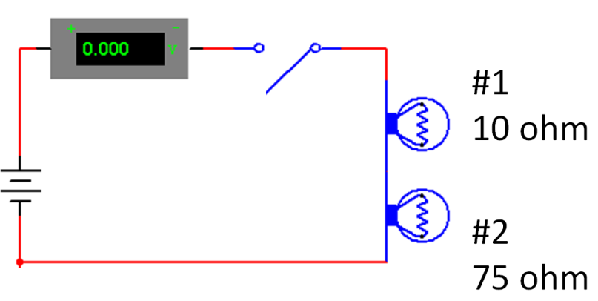

Current ______________A Voltage across battery _________V

Voltage across bulb #1 _________V Voltage across bulb #2 _______V

- Close the switch. Record the new readings for the circuit.
Current ______________A Voltage across battery _________V

Voltage across bulb #1 _________V Voltage across bulb #2 _______V

Add an ammeter between the bulbs and record the current.

Current between bulbs ______________A

- Use the voltage (V) and current that you have already determined for this series circuit current (I) to determine the resistance of the bulbs in series. Show your work and include units.

Formula:

Substitute values:

Solve:

Resistance = _______________Ω

Creating a Parallel Circuit
- Create the circuit shown below with the switch open. Confirm that: bulb 1 is on and bulb 2 is off.
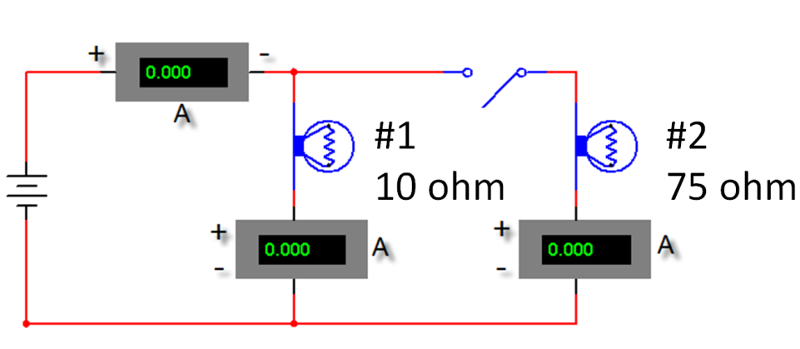

Close the switch and record the following data.
What happened to brightness of the 1st bulb? ______________________________

Which bulb is brighter? ____________________________

Current at bulb #1 ______________A

Current at bulb #2 ______________A
Current total _______________A

- Add a voltmeter to the circuit. Record the voltages across each light and the output source in the space provided below.

Bulb #1 ________________V Bulb #2 _________________V

Output at the battery ________________V

- Calculate total resistance for the circuit (show all work):
Formula:
Substitute and solve:
R_{T}__________ Ω

Creating a Combination Circuit
- Create the circuit shown below. The bulb #1 should still be on, the current meter should have the same measurement as in step 8, and the bulb #2 and #3 should be off. Close the switch button and note what happens to the first light. Refer to the image below and record the new current measurement in the space provided below the image.

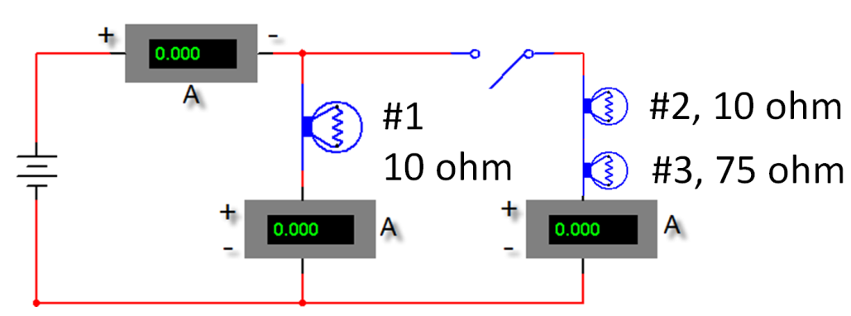

Voltage across battery _________V

Voltage across bulb #1 _________V Voltage across bulb #2 _______V

Voltage across bulb #3 _______V

Current at bulb #1 ______________A

Current at bulb #2 and #3 ______________A

Total current ______________A
Conclusion

- Explain the primary difference between a series and a parallel circuit.

- Explain the difference between the voltage output at the battery and the voltage across each bulb in the series circuit.

- In a series circuit, explain the relationship between the current at the battery and each bulb in the circuit.

- Explain the relationship between voltage at the battery and voltage across each bulb in a parallel circuit.

- Explain the relationship between current at the battery and current through each bulb in the parallel circuit.

- For the combination circuit, explain the relationship between the voltage output at the interface and the voltage across the two light bulbs.

- For the combination circuit, explain the relationship between the current output at the battery and the current through each bulb in the parallel circuit.

