Project 1.2.10 Glider Design Challenge #1

Introduction
Have you ever tried to fly a glider? Have you made something with balsa wood before? In this project you will learn to do both. This design challenge provides glider constraints to create a glider design using the AERY software package.

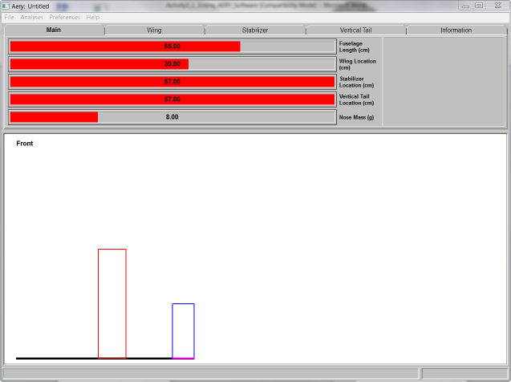

Equipment
- Engineering notebook
- Pencil
- PC with AERY glider design software
- Printer

Procedure
- Use the Challenge One glider constraints shown below.
Main: |  | Stabilizer:
Fuselage Length (cm) | 30 | Span (cm) | 25
Wing Location (cm) | 13 | Root Chord (cm) | 8
Stabilizer Location (cm) | 22 | Taper Ratio | 0.6
Vertical Location (cm) | 22 | Leading Edge Sweep Angle | 15
Nose Mass (g) | 8
Wing: |  | Vertical Tail:
Span (cm) | 50 | Height (cm) | 10
Root Chord (cm) | 10 | Root Chord (cm) | 8
Taper Ratio | 1.0 | Taper Ratio | 0.7
Leading Edge Sweep Angle | 0 | Leading Edge Sweep Angle | 15
Launch Velocity (km/hr) | 20

- Start the AERY glider design software.
- Click File then New Design.
- Create a glider design that meets the constraints provided.
- Modify the design as necessary to achieve stability. Confirm the aircraft stability by clicking Analysis then Will It Fly?
- When your design is stable, print out two copies of the design.
- Save the design to the location indicated by the teacher.
- Enter one design print in your engineering notebook for use with the Challenge Two. The second print will be for your final design report.

Conclusion

- Explain which glider or aircraft term were difficult to understand and the correct definition.

- Explain any challenges if someone else were to construct your design using the AERY print.

- Explain any challenges faced using the AERY software and how you overcame those challenges.

